**Lab 05: GUI Programming**

Họ và Tên : Trịnh Minh Đạt

MSSV: 20225701

Link Github: https://github.com/Dathazayuki/OOP5-20225701-Tr-nh-Minh--t

# Swing components

## **AWTAccumulator**

### Create class AWTAccumulator with the source code as below

Code :

**package** hust.soict.dsai.swing;

**import** java.awt.*;

**import** java.awt.event.*;

**public** **class** AWTAccumulator **extends** Frame {

/**

*

*/

**private** **static** **final** **long** ***serialVersionUID*** = 1L;

**private** TextField tfInput;

**private** TextField tfOutput;

**private** **int** sum = 0; // Accumulated sum, init to 0

// Constructor to setup the GUI components and event handlers

**public** AWTAccumulator() {

setLayout(**new** GridLayout(2, 2));

add(**new** Label("Enter an Integer: "));

tfInput = **new** TextField(10);

add(tfInput);

tfInput.addActionListener(**new** TFInputListener());

add(**new** Label("The Accumulated Sum is: "));

tfOutput = **new** TextField(10);

tfOutput.setEditable(**false**);

add(tfOutput);

setTitle("AWT Accumulator");

setSize(350, 120);

setVisible(**true**);

}

**public** **static** **void** main(String[] args) {

**new** AWTAccumulator();

}

**private** **class** TFInputListener **implements** ActionListener {

@Override

**public** **void** actionPerformed(ActionEvent evt) {

**int** numberIn = Integer.*parseInt*(tfInput.getText());

sum += numberIn;

tfInput.setText("");

tfOutput.setText(sum + "");

}

}

}

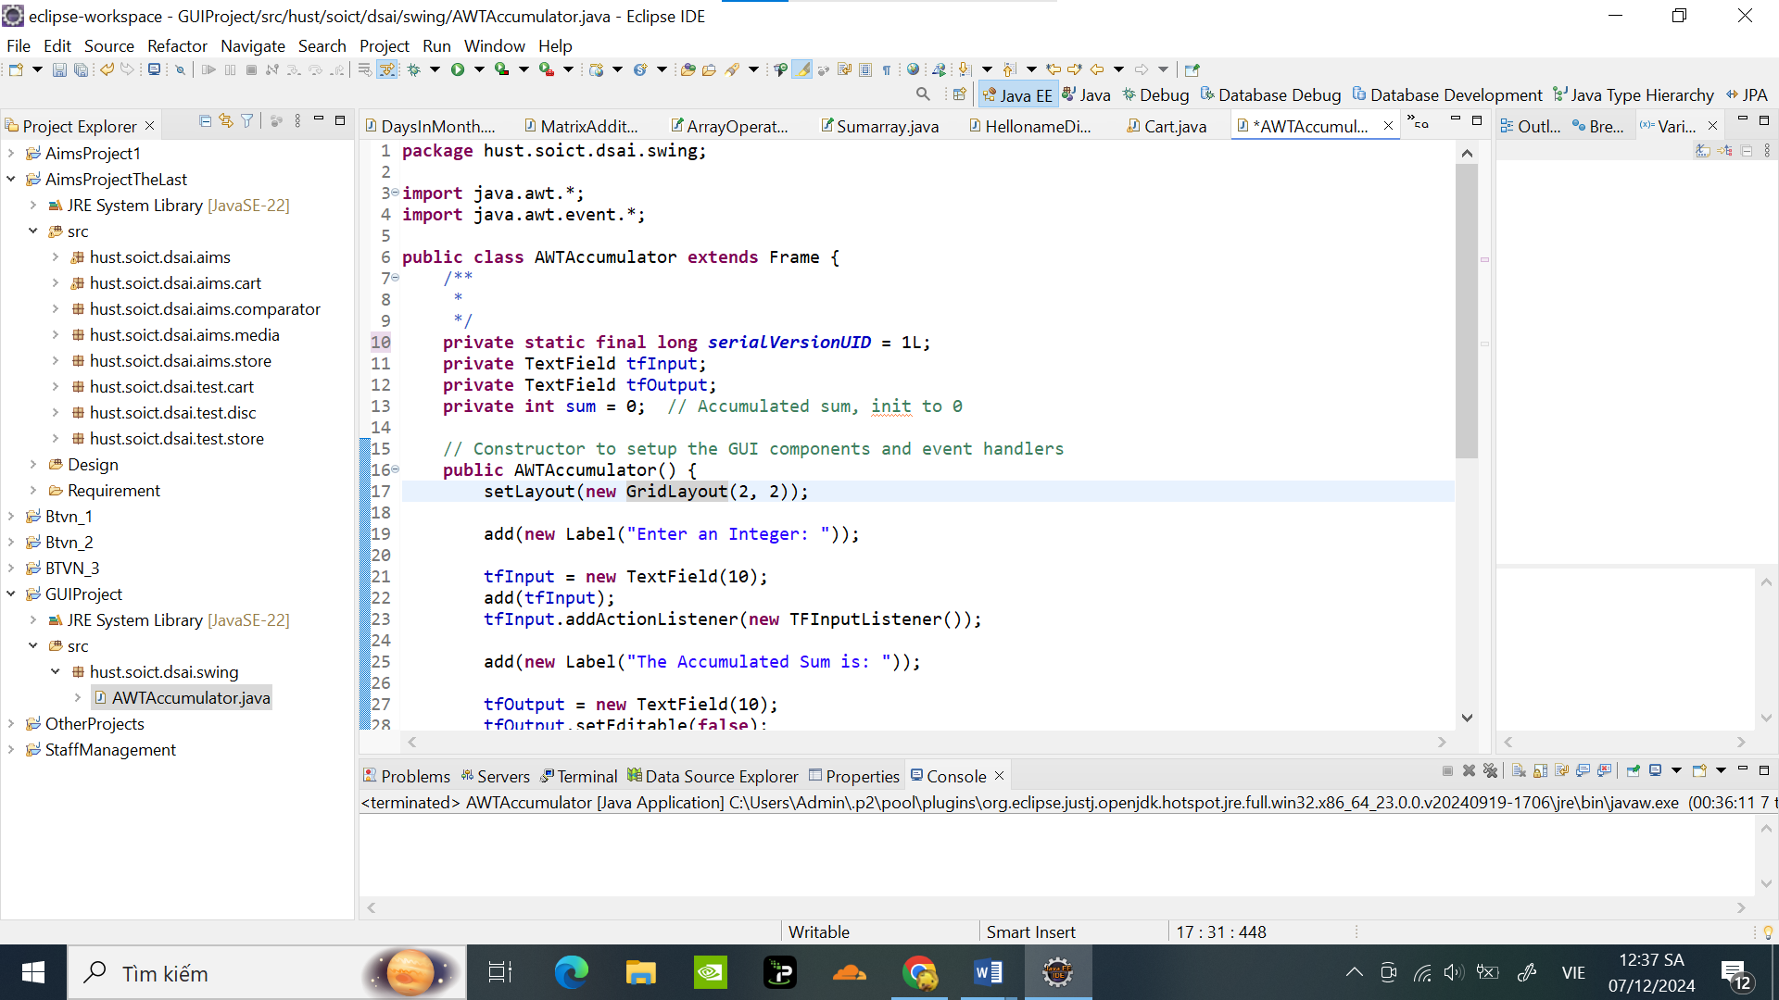

Khi chạy chương trình sẽ hiển thị 1 cửa sổ ứng dụng mới cho phép tính tổng các số được nhập vào thành 1 tổng số:

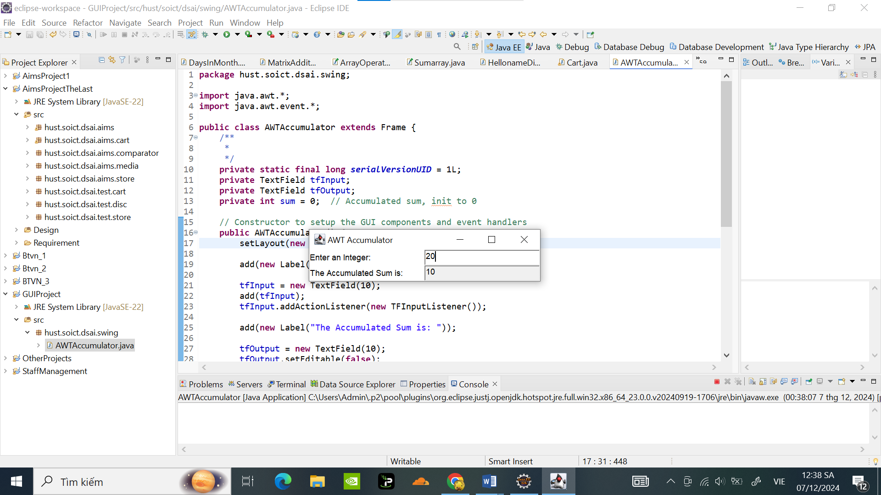

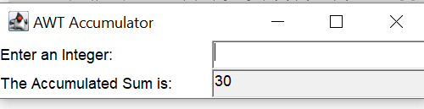

## **SwingAccumulator**

### Create class SwingAccumulator with the source code as below:

Code :

**package** hust.soict.dsai.swing;

**import** javax.swing.*;

**import** java.awt.*;

**import** java.awt.event.*;

**public** **class** SwingAccumulator **extends** JFrame {

/**

*

*/

**private** **static** **final** **long** ***serialVersionUID*** = 1L;

**private** JTextField tfInput;

**private** JTextField tfOutput;

**private** **int** sum = 0; // Accumulated sum, init to 0

// Constructor to setup the GUI components and event handlers

**public** SwingAccumulator() {

Container cp = getContentPane();

cp.setLayout(**new** GridLayout(2, 2));

cp.add(**new** JLabel("Enter an Integer: "));

tfInput = **new** JTextField(10);

cp.add(tfInput);

tfInput.addActionListener(**new** TFInputListener());

cp.add(**new** JLabel("The Accumulated Sum is: "));

tfOutput = **new** JTextField(10);

tfOutput.setEditable(**false**);

cp.add(tfOutput);

setTitle("Swing Accumulator");

setSize(350, 120);

setVisible(**true**);

}

**public** **static** **void** main(String[] args) {

**new** SwingAccumulator();

}

**private** **class** TFInputListener **implements** ActionListener {

@Override

**public** **void** actionPerformed(ActionEvent evt) {

**int** numberIn = Integer.*parseInt*(tfInput.getText());

sum += numberIn;

tfInput.setText("");

tfOutput.setText(sum + "");

}

}

}

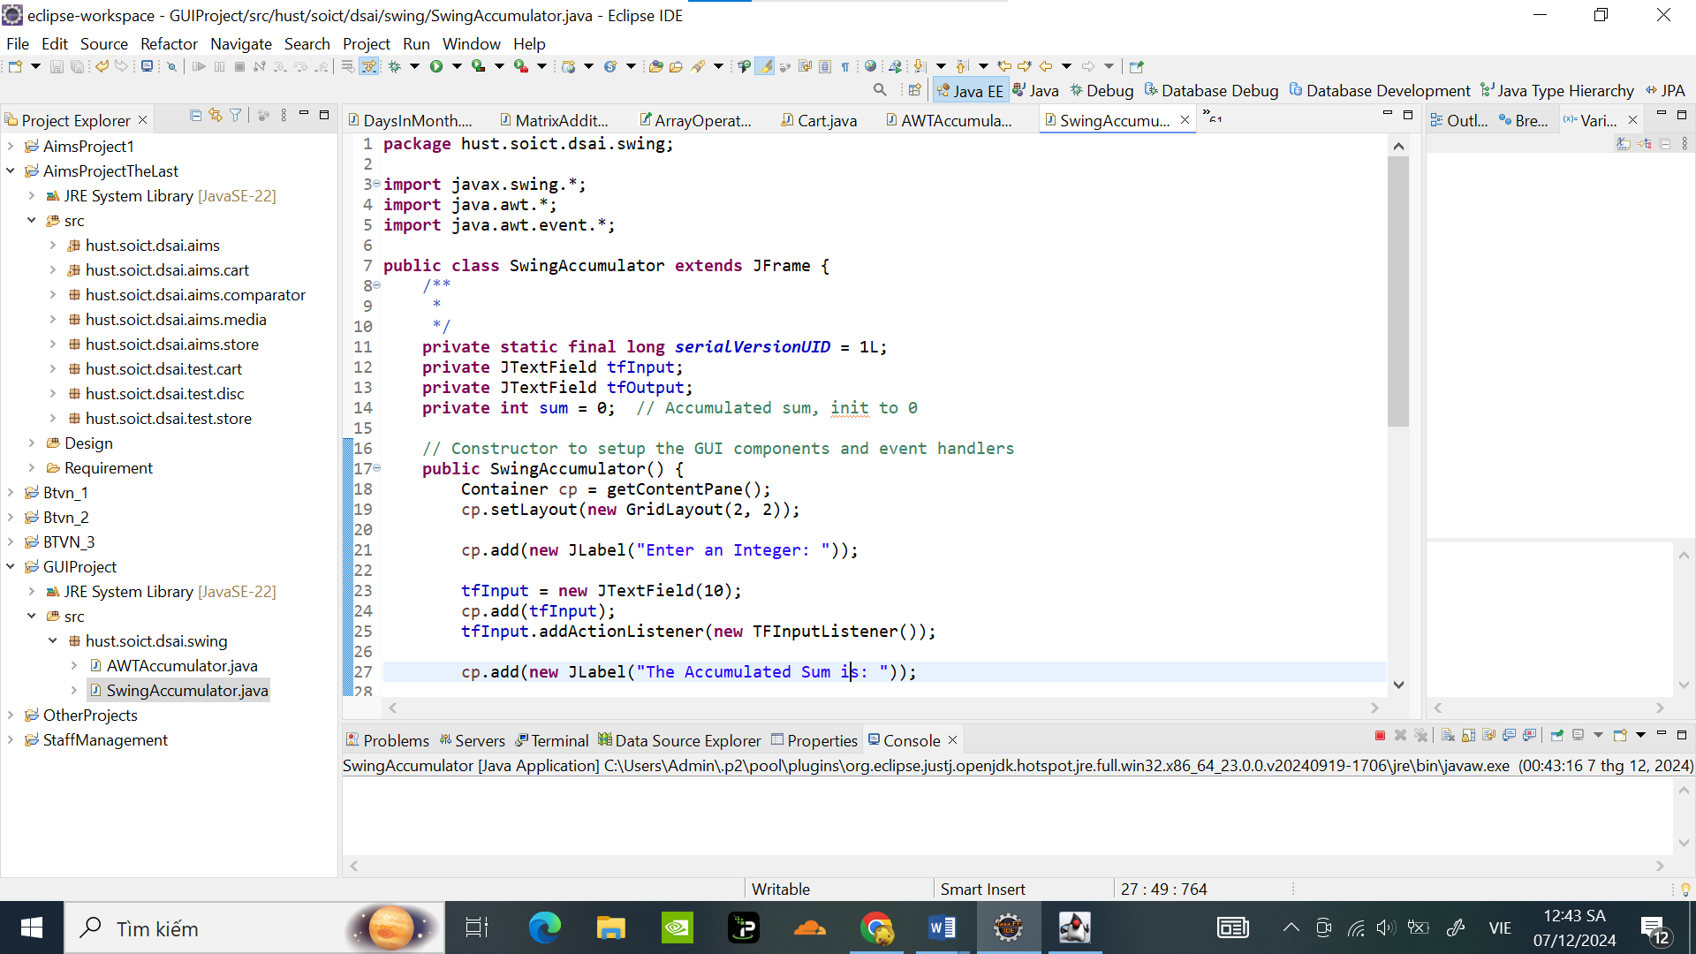

Kết quả chạy chương trình cũng tương tự AWT , cho ra 1 cửa sổ ứng dụng tính tổng các phần tử nhập vào :

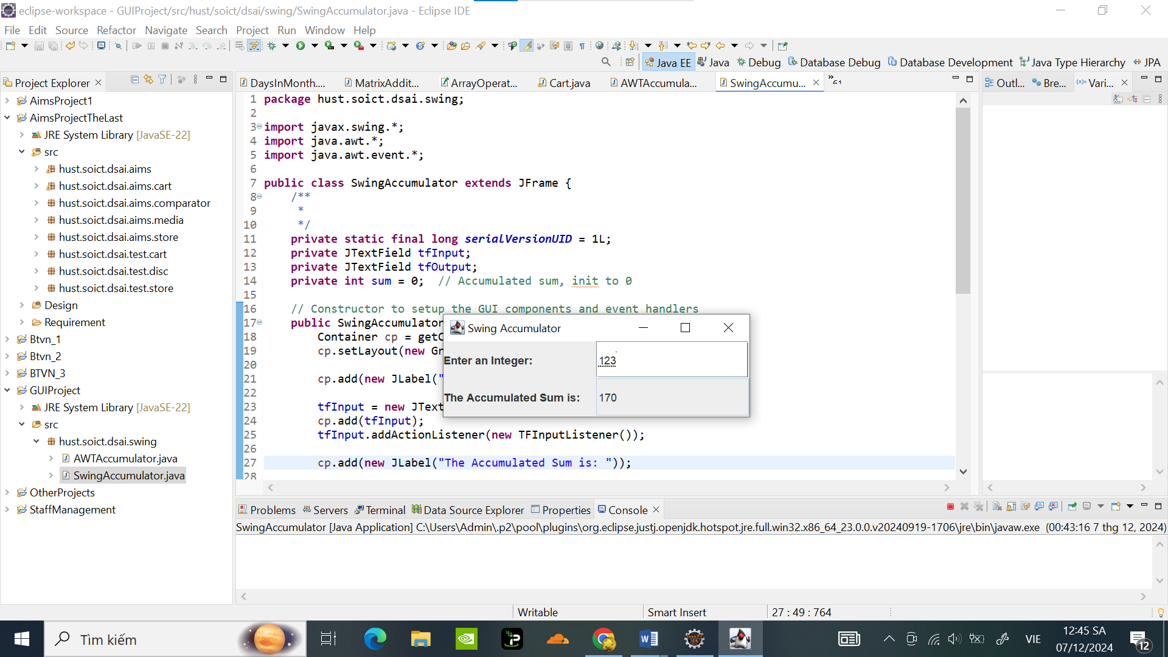

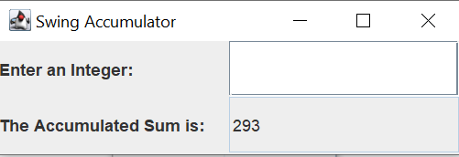

## Compare Swing and AWT elements

#### A,. **Các container cấp cao nhất trong Swing và AWT**

| **Đặc điểm** | **AWT (Abstract Window Toolkit)** | **Swing** |
| --- | --- | --- |
| **Container cấp cao nhất** | - Frame | - JFrame |
|  | - Dialog | - JDialog |
|  | - Applet | - JApplet |
| **Sử dụng** | Sử dụng các thành phần gốc của hệ điều hành. | Thuần Java, nhẹ, dễ tùy chỉnh. |
| **Giao diện người dùng** | Phụ thuộc vào nền tảng. | Hỗ trợ giao diện người dùng có thể thay đổi. |

#### B , **Tên lớp thành phần trong AWT và tên lớp tương ứng trong Swing**

| **Lớp trong AWT** | **Lớp tương ứng trong Swing** | **Sự khác biệt/Ghi chú** |
| --- | --- | --- |
| Button | JButton | JButton cung cấp thêm các tính năng như hỗ trợ icon. |
| Label | JLabel | JLabel hỗ trợ hiển thị HTML và icon. |
| TextField | JTextField | JTextField có nhiều tùy chọn hơn. |
| TextArea | JTextArea | Tương tự, nhưng JTextArea hỗ trợ nhiều kiểu hiển thị hơn. |
| Checkbox | JCheckBox | JCheckBox nằm trong gói javax.swing. |
| Choice | JComboBox | Swing sử dụng JComboBox cho danh sách thả xuống. |
| List | JList | JList trong Swing linh hoạt hơn. |
| Scrollbar | JScrollBar | Cả hai đều thực hiện chức năng tương tự. |
| Panel | JPanel | JPanel hỗ trợ bố cục lồng nhau và nhiều tính năng hơn. |
| Canvas | JPanel | JPanel thường được sử dụng thay cho Canvas. |
| MenuBar | JMenuBar | Linh hoạt và nhiều tính năng hơn trong Swing. |
| Menu | JMenu | Tương tự nhưng thuộc gói Swing. |

* Khi chuyển từ AWT sang Swing, sự khác biệt lớn nằm ở quy ước đặt tên và các tính năng bổ sung mà Swing cung cấp (như hỗ trợ icon, hiển thị HTML, và giao diện người dùng có thể thay đổi).
* Trong các ứng dụng hiện đại, Swing thường được ưa chuộng hơn AWT nhờ tính linh hoạt và các chức năng nâng cao của nó

# Organizing Swing components with Layout Managers

## Swing top-level and secondary-level containers

## Using JPanel as secondary-level container to organize components

### 2.2.1-2.2.2 . Create class NumberGrid

Code :

**package** hust.soict.dsai.swing;

**import** java.awt.BorderLayout;

**import** java.awt.ComponentOrientation;

**import** java.awt.Container;

**import** java.awt.GridLayout;

**import** javax.swing.JButton;

**import** javax.swing.JFrame;

**import** javax.swing.JPanel;

**import** javax.swing.JTextField;

**public** **class** NumberGrid **extends** JFrame {

**private** **static** **final** **long** ***serialVersionUID*** = 1L;

**private** JButton[] btnNumbers = **new** JButton[10];

**private** JButton btnDelete, btnReset;

**private** JTextField tfDisplay;

**public** NumberGrid() {

tfDisplay = **new** JTextField();

tfDisplay.setComponentOrientation(ComponentOrientation.***RIGHT_TO_LEFT***);

JPanel panelButtons = **new** JPanel(**new** GridLayout(4, 3));

addButtons(panelButtons);

Container cp = getContentPane();

cp.setLayout(**new** BorderLayout());

cp.add(tfDisplay, BorderLayout.***NORTH***);

cp.add(panelButtons, BorderLayout.***CENTER***);

setDefaultCloseOperation(JFrame.***EXIT_ON_CLOSE***);

setTitle("Number Grid");

setSize(200, 200);

setVisible(**true**);

}

**void** addButtons(JPanel panelButtons) {

ButtonListener btnListener = **new** ButtonListener(tfDisplay);

**for** (**int** i = 0; i < 9; i++) {

btnNumbers[i] = **new** JButton(String.*valueOf*(i +1));

panelButtons.add(btnNumbers[i]);

btnNumbers[i].addActionListener(btnListener); // Thêm listener cho nút

}

btnDelete = **new** JButton("DEL");

panelButtons.add(btnDelete);

btnDelete.addActionListener(btnListener);

btnNumbers[0] = **new** JButton(String.*valueOf*(0));

panelButtons.add(btnNumbers[0]);

btnNumbers[0].addActionListener(btnListener);

btnReset = **new** JButton("C");

panelButtons.add(btnReset);

btnReset.addActionListener(btnListener);

}

**public** **static** **void** main(String[] args) {

**new** NumberGrid(); // Tạo và hiển thị giao diện NumberGrid

}

}

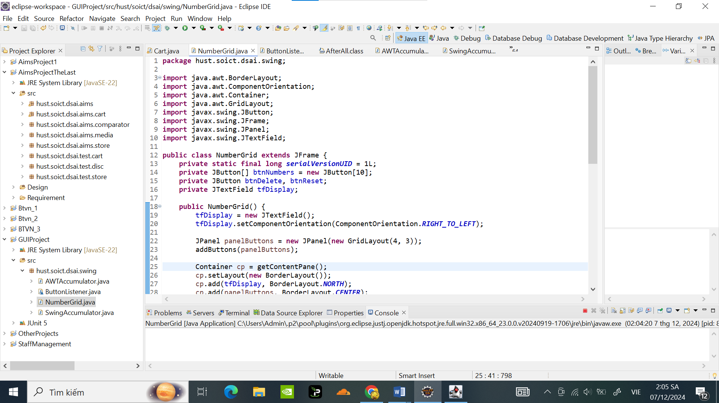

### Complete inner class ButtonListener

Code:

**package** hust.soict.dsai.swing;

**import** java.awt.event.ActionEvent;

**import** java.awt.event.ActionListener;

**import** javax.swing.JTextField;

**class** ButtonListener **implements** ActionListener {

**private** JTextField tfDisplay;

**public** ButtonListener(JTextField tfDisplay) {

**this**.tfDisplay = tfDisplay;

}

**public** **void** actionPerformed(ActionEvent e) {

String button = e.getActionCommand();

**if** (button.charAt(0) >= '0' && button.charAt(0) <= '9') {

tfDisplay.setText(tfDisplay.getText() + button);

} **else** **if** (button.equals("DEL")) {

String currentText = tfDisplay.getText();

**if** (currentText.length() > 0) {

tfDisplay.setText(currentText.substring(0, currentText.length() - 1)); // Xóa ký tự cuối cùng

}

} **else** {

tfDisplay.setText("");

}

}

}

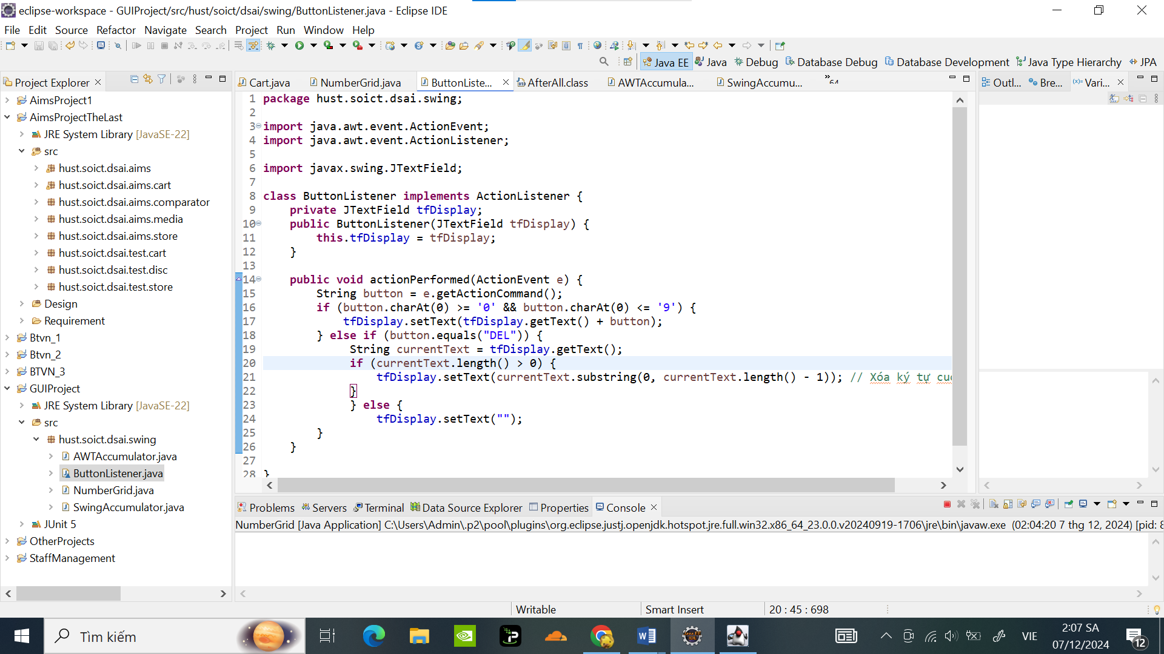

Kết quả chạy chương trình hiển thị giao diện NumberGrid:

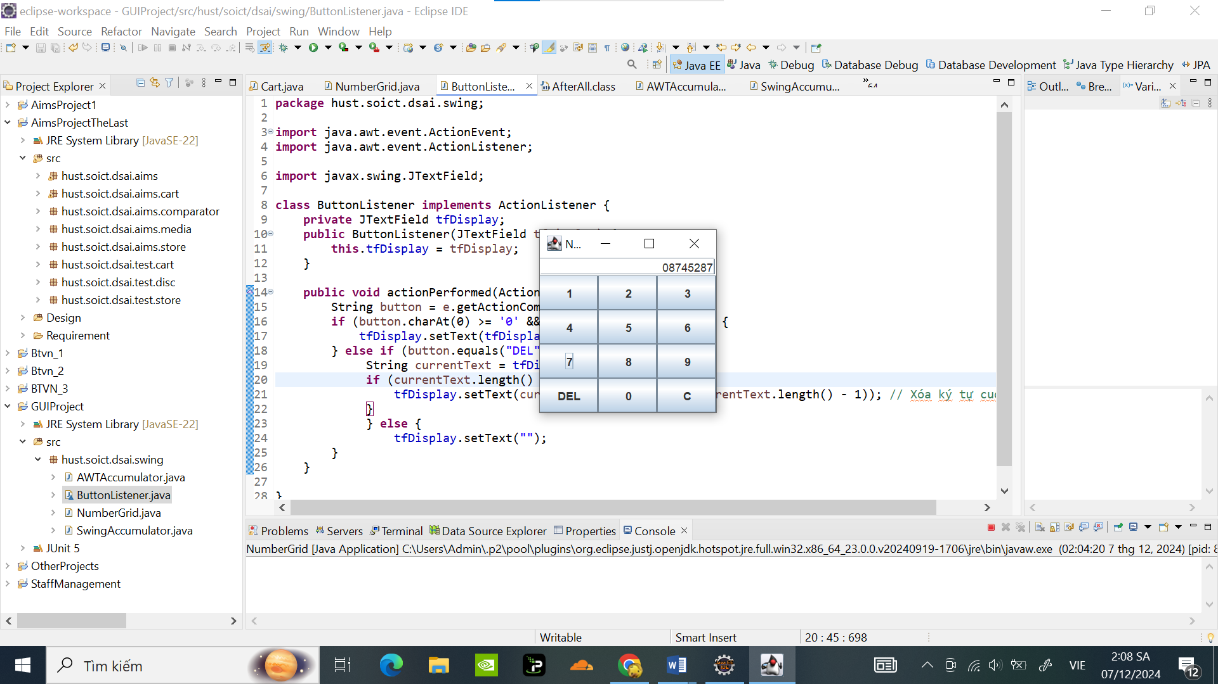

Chức năng “DEL”: Xóa 1 kí tự

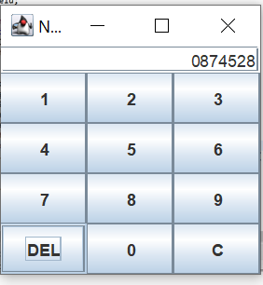

Chức năng “C” : Xóa hết ký tự

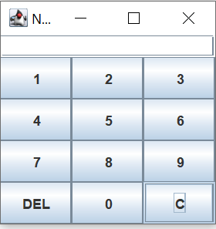

# Create a graphical user interface for AIMS with Swing

### Create the StoreScreen class

Code:

**package** hust.soict.dsai.aims.screen;

**import** java.awt.BorderLayout;

**import** java.awt.Color;

**import** java.awt.Container;

**import** java.awt.Dimension;

**import** java.awt.FlowLayout;

**import** java.awt.Font;

**import** java.awt.GridLayout;

**import** javax.swing.Box;

**import** javax.swing.BoxLayout;

**import** javax.swing.JButton;

**import** javax.swing.JFrame;

**import** javax.swing.JLabel;

**import** javax.swing.JMenu;

**import** javax.swing.JMenuBar;

**import** javax.swing.JMenuItem;

**import** javax.swing.JPanel;

**import** hust.soict.dsai.aims.store.Store;

**import** hust.soict.dsai.aims.cart.Cart;

**import** hust.soict.dsai.aims.media.Book;

**import** hust.soict.dsai.aims.media.CompactDisc;

**import** hust.soict.dsai.aims.media.DigitalVideoDisc;

**import** hust.soict.dsai.aims.media.Media;

**import** java.util.ArrayList;

**public** **class** StoreScreen **extends** JFrame {

/**

*

*/

**private** **static** **final** **long** ***serialVersionUID*** = 1L;

**private** **static** Store *store*;

**public** StoreScreen(Store store) {

store = **new** Store();

// Example media added to the store

DigitalVideoDisc dvd1 = **new** DigitalVideoDisc( "Inception", "Sci-Fi", "Christopher Nolan", 148, 19.99f);

DigitalVideoDisc dvd2 = **new** DigitalVideoDisc( "Tranformers", "action", "Micheal Bay", 198, 39.99f);

Book book1 = **new** Book( "conan", "anime", 15.99f, **new** ArrayList<>());

Book book2 = **new** Book( "doraemon", "anime", 12.45f, **new** ArrayList<>());

Book book3 = **new** Book( "Effective Java", "Programming", 45.99f, **new** ArrayList<>());

CompactDisc cd1 = **new** CompactDisc("Greatest Hits", "Music","Godfather" ,134, 14.99f,"J-97");

CompactDisc cd2 = **new** CompactDisc("Don't stop me now", "Music","Mamaday" ,167, 22.99f,"hololive");

store.addMedia(dvd1);

store.addMedia(dvd2);

store.addMedia(book1);

store.addMedia(book2);

store.addMedia(book3);

store.addMedia(cd1);

store.addMedia(cd2);

StoreScreen.*store* = store;

Container cp = getContentPane();

cp.setLayout(**new** BorderLayout());

cp.add(createNorth(), BorderLayout.***NORTH***);

cp.add(createCenter(), BorderLayout.***CENTER***);

setVisible(**true**);

setTitle("Store");

setSize(1024, 768);

}

JPanel createNorth() {

JPanel north = **new** JPanel();

north.setLayout(**new** BoxLayout(north, BoxLayout.***Y_AXIS***));

north.add(createMenuBar());

north.add(createHeader());

**return** north;

}

JMenuBar createMenuBar() {

JMenu menu = **new** JMenu("Options");

JMenu smUpdateStore = **new** JMenu("Update Store");

smUpdateStore.add(**new** JMenuItem("Add Book"));

smUpdateStore.add(**new** JMenuItem("Add CD"));

smUpdateStore.add(**new** JMenuItem("Add DVD"));

menu.add(smUpdateStore);

menu.add(**new** JMenuItem("View store"));

menu.add(**new** JMenuItem("View Cart"));

JMenuBar menuBar = **new** JMenuBar();

menuBar.setLayout(**new** FlowLayout(FlowLayout.***LEFT***));

menuBar.add(menu);

**return** menuBar;

}

JPanel createHeader() {

JPanel header = **new** JPanel();

header.setLayout(**new** BoxLayout(header, BoxLayout.***X_AXIS***));

JLabel title = **new** JLabel("AIMS");

title.setFont(**new** Font(title.getFont().getName(), Font.***PLAIN***, 20));

title.setForeground(Color.***CYAN***);

JButton cart = **new** JButton("View cart");

cart.setPreferredSize(**new** Dimension(100, 50));

cart.setMaximumSize(**new** Dimension(100, 50));

header.add(Box.*createRigidArea*(**new** Dimension(10, 0)));

header.add(title);

header.add(Box.*createHorizontalGlue*());

header.add(cart);

**return** header;

}

JPanel createCenter() {

JPanel center = **new** JPanel();

center.setLayout(**new** GridLayout(3, 3, 2, 2));

ArrayList<Media> itemsInStore = *store*.getItems(); // Lấy danh sách media từ store

**if** (itemsInStore != **null** && !itemsInStore.isEmpty()) {

**for** (**int** i = 0; i < Math.*min*(9, itemsInStore.size()); i++) {

Media mediaItem = itemsInStore.get(i);

Cart cart = **new** Cart();

MediaStore cell = **new** MediaStore(mediaItem, cart); // Tạo đối tượng MediaStore

center.add(cell); // Thêm vào center panel

}

}

**return** center;

}

**public** **static** **void** main(String[] args) {

**new** StoreScreen(*store*);

}

}

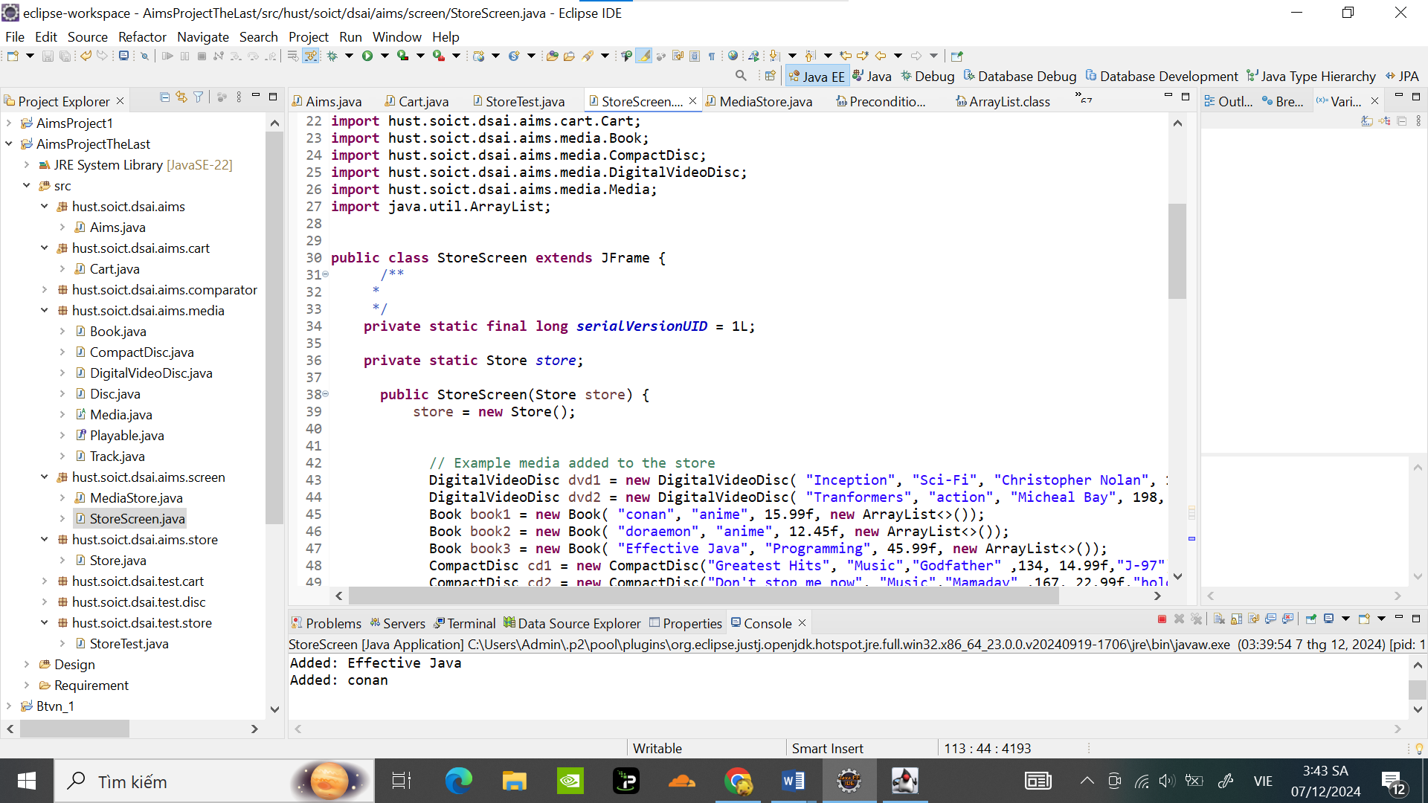

### The MediaStore class

Code:

**package** hust.soict.dsai.aims.screen;

**import** java.awt.Color;

**import** java.awt.FlowLayout;

**import** java.awt.Font;

**import** java.awt.event.ActionEvent;

**import** java.awt.event.ActionListener;

**import** javax.swing.BorderFactory;

**import** javax.swing.Box;

**import** javax.swing.BoxLayout;

**import** javax.swing.JButton;

**import** javax.swing.JDialog;

**import** javax.swing.JLabel;

**import** javax.swing.JOptionPane;

**import** javax.swing.JPanel;

**import** hust.soict.dsai.aims.cart.Cart;

**import** hust.soict.dsai.aims.media.Media;

**import** hust.soict.dsai.aims.media.Playable;

**public** **class** MediaStore **extends** JPanel {

/**

*

*/

**private** **static** **final** **long** ***serialVersionUID*** = 1L;

**private** Media media;

**private** Cart cart;

**public** MediaStore(Media media,Cart cart) {

**this**.setMedia(media);

**this**.cart = cart;

setLayout(**new** BoxLayout(**this**, BoxLayout.***Y_AXIS***));

JLabel title = **new** JLabel(media.getTitle());

title.setFont(**new** Font(title.getFont().getName(), Font.***PLAIN***, 20));

title.setAlignmentX(***CENTER_ALIGNMENT***);

JLabel cost = **new** JLabel(media.getCost() + "$");

cost.setAlignmentX(***CENTER_ALIGNMENT***);

JPanel container = **new** JPanel(**new** FlowLayout(FlowLayout.***CENTER***));

JButton addToCartButton = **new** JButton("Add to cart");

addToCartButton.addActionListener(**new** ActionListener() {

@Override

**public** **void** actionPerformed(ActionEvent e) {

// Thêm media vào giỏ hàng

cart.addMedia(media);

JOptionPane.*showMessageDialog*(**null**, media.getTitle() + " has been added to cart.");

}

});

container.add(addToCartButton);

**if** (media **instanceof** Playable) {

// Tạo nút "Play"

JButton playButton = **new** JButton("Play");

// Gán ActionListener cho nút "Play"

playButton.addActionListener(**new** ActionListener() {

@Override

**public** **void** actionPerformed(ActionEvent e) {

// Hiển thị media trong một cửa sổ dialog (mô phỏng phát media)

JDialog playDialog = **new** JDialog();

playDialog.setTitle("Video is playing: " + media.getTitle());

playDialog.setSize(400, 200);

playDialog.setLocationRelativeTo(**null**); // Canh giữa cửa sổ dialog

playDialog.setDefaultCloseOperation(JDialog.***DISPOSE_ON_CLOSE***);

// Mô phỏng việc phát media bằng cách hiển thị một thông báo

JLabel playingLabel = **new** JLabel("Video is playing: " + media.getTitle(), JLabel.***CENTER***);

playDialog.add(playingLabel);

playDialog.setVisible(**true**);

}

});

// Thêm nút "Play" vào container

container.add(playButton);

}

container.add(Box.*createVerticalGlue*());

**this**.add(Box.*createVerticalGlue*());

**this**.add(title);

**this**.add(cost);

**this**.add(container);

**this**.setBorder(BorderFactory.*createLineBorder*(Color.***BLACK***));

}

**public** Cart getCart() {

**return** cart;

}

**public** **void** setCart(Cart cart) {

**this**.cart = cart;

}

**public** Media getMedia() {

**return** media;

}

**public** **void** setMedia(Media media) {

**this**.media = media;

}

}

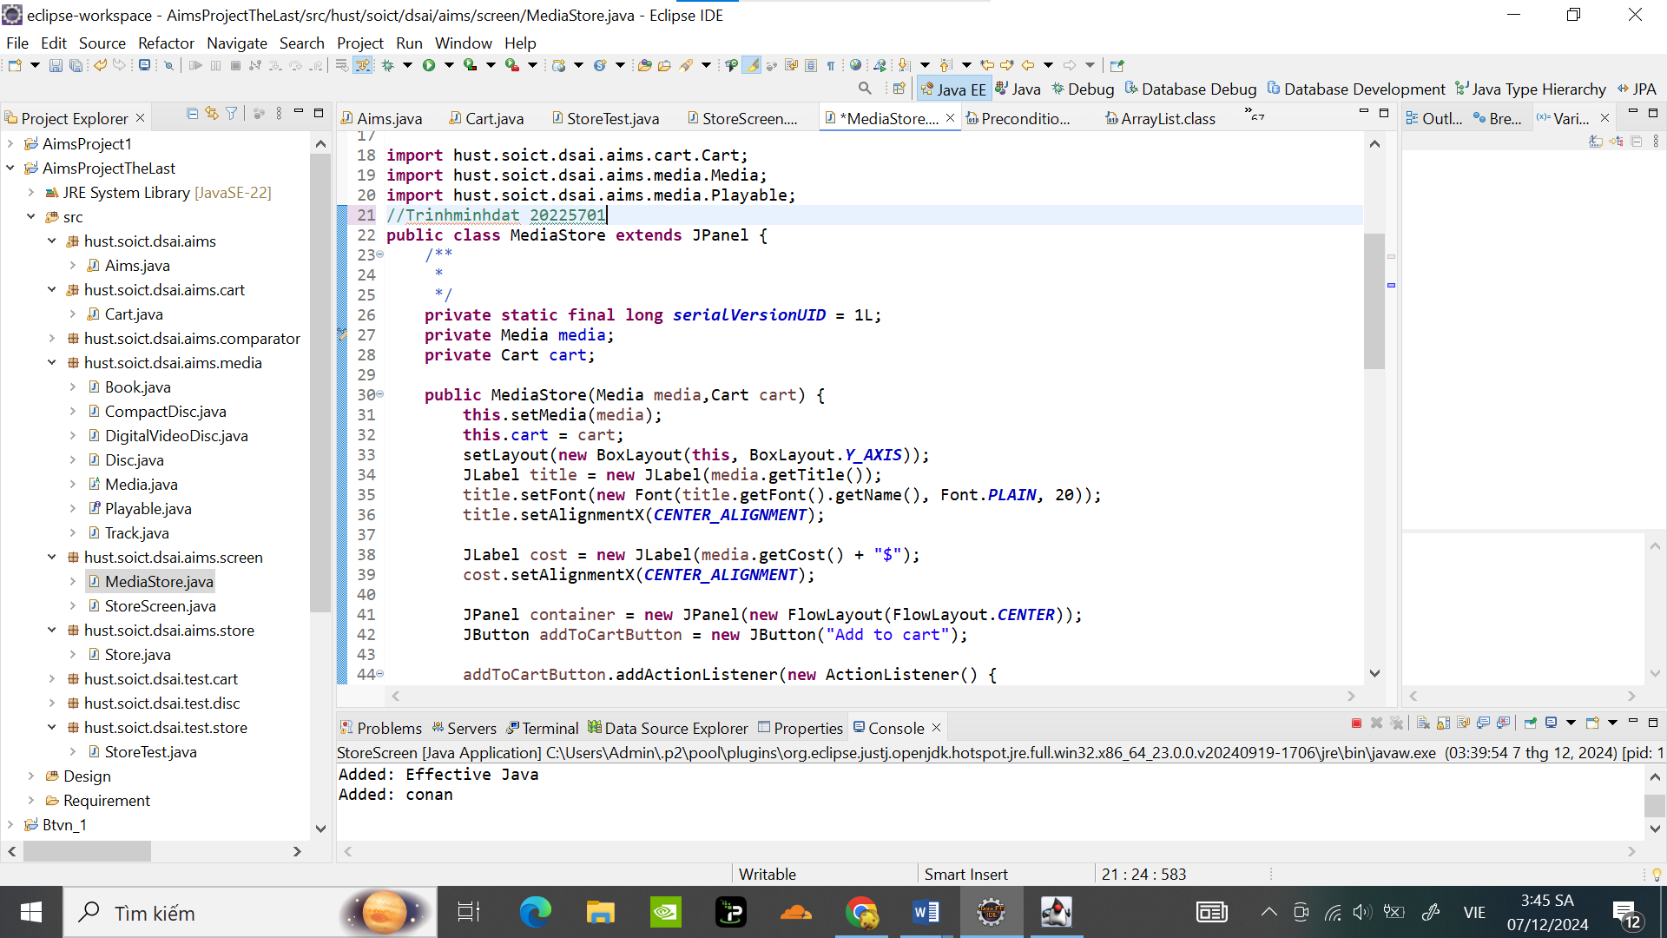

Giao diện :

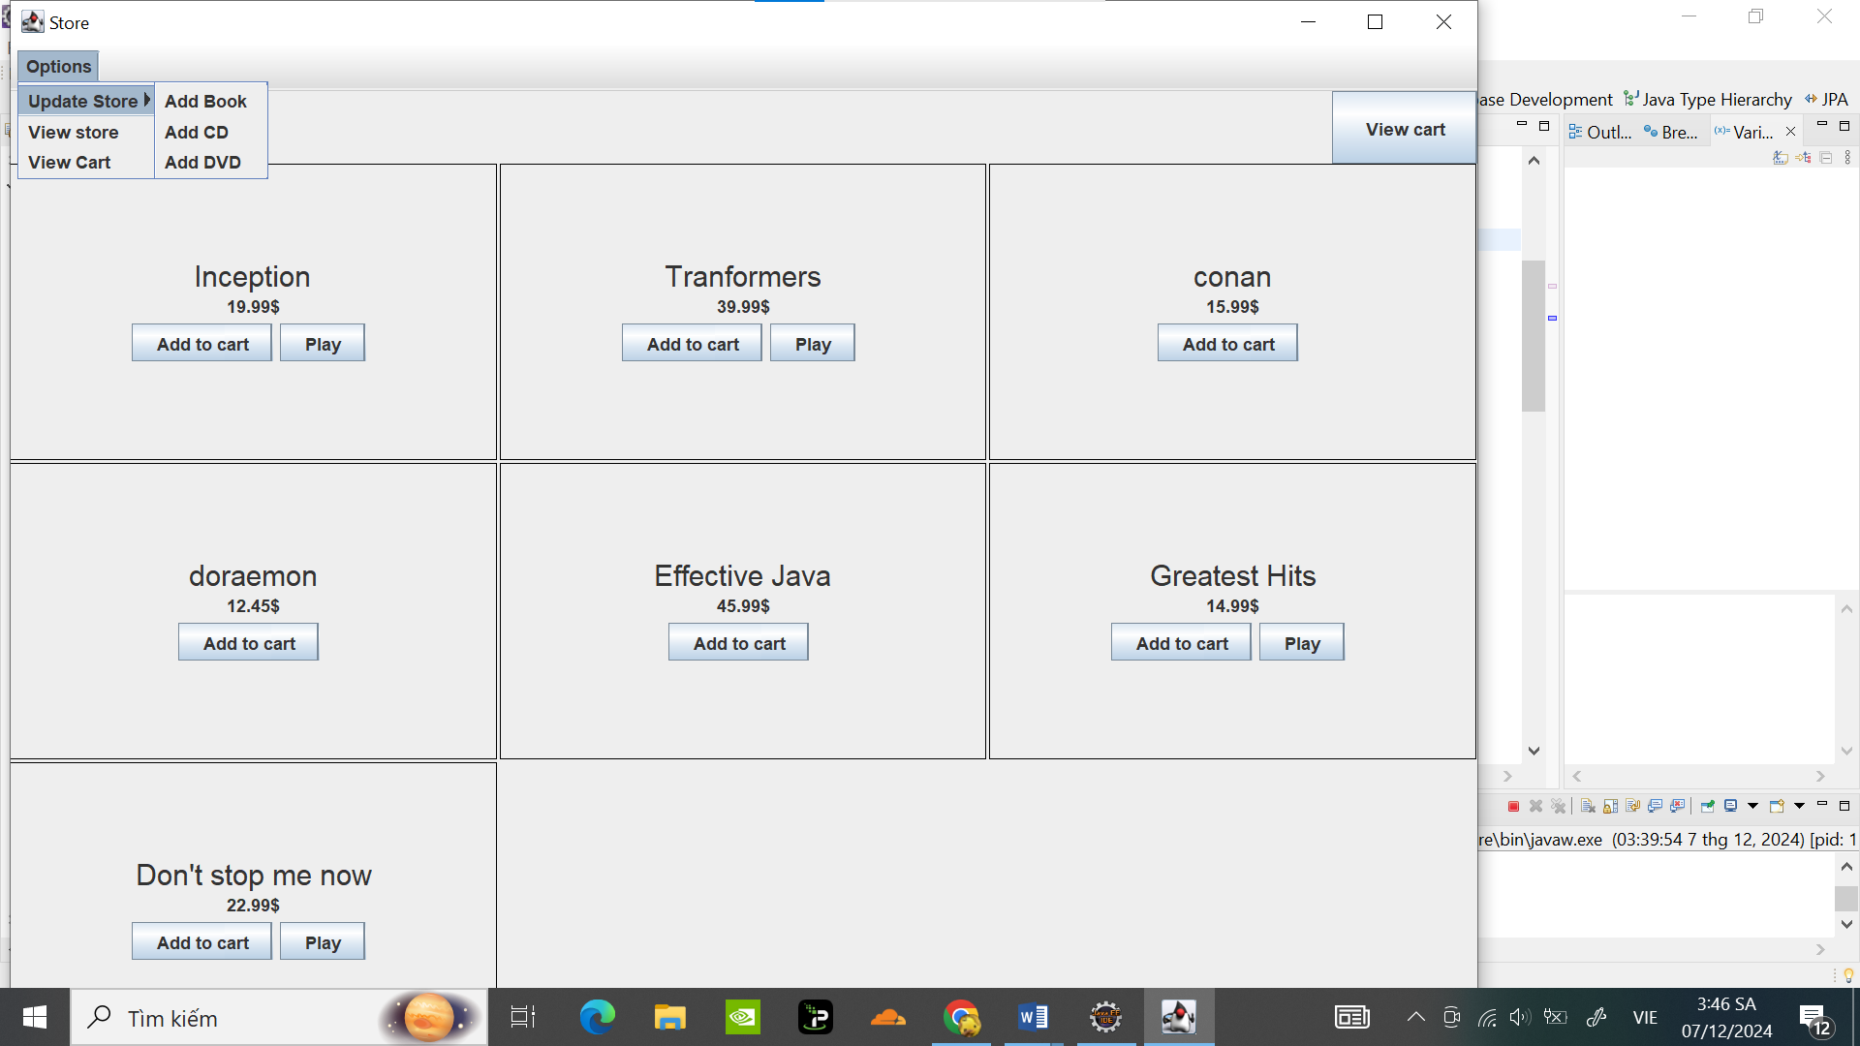

## Adding more user interaction

Bâms add to cart :

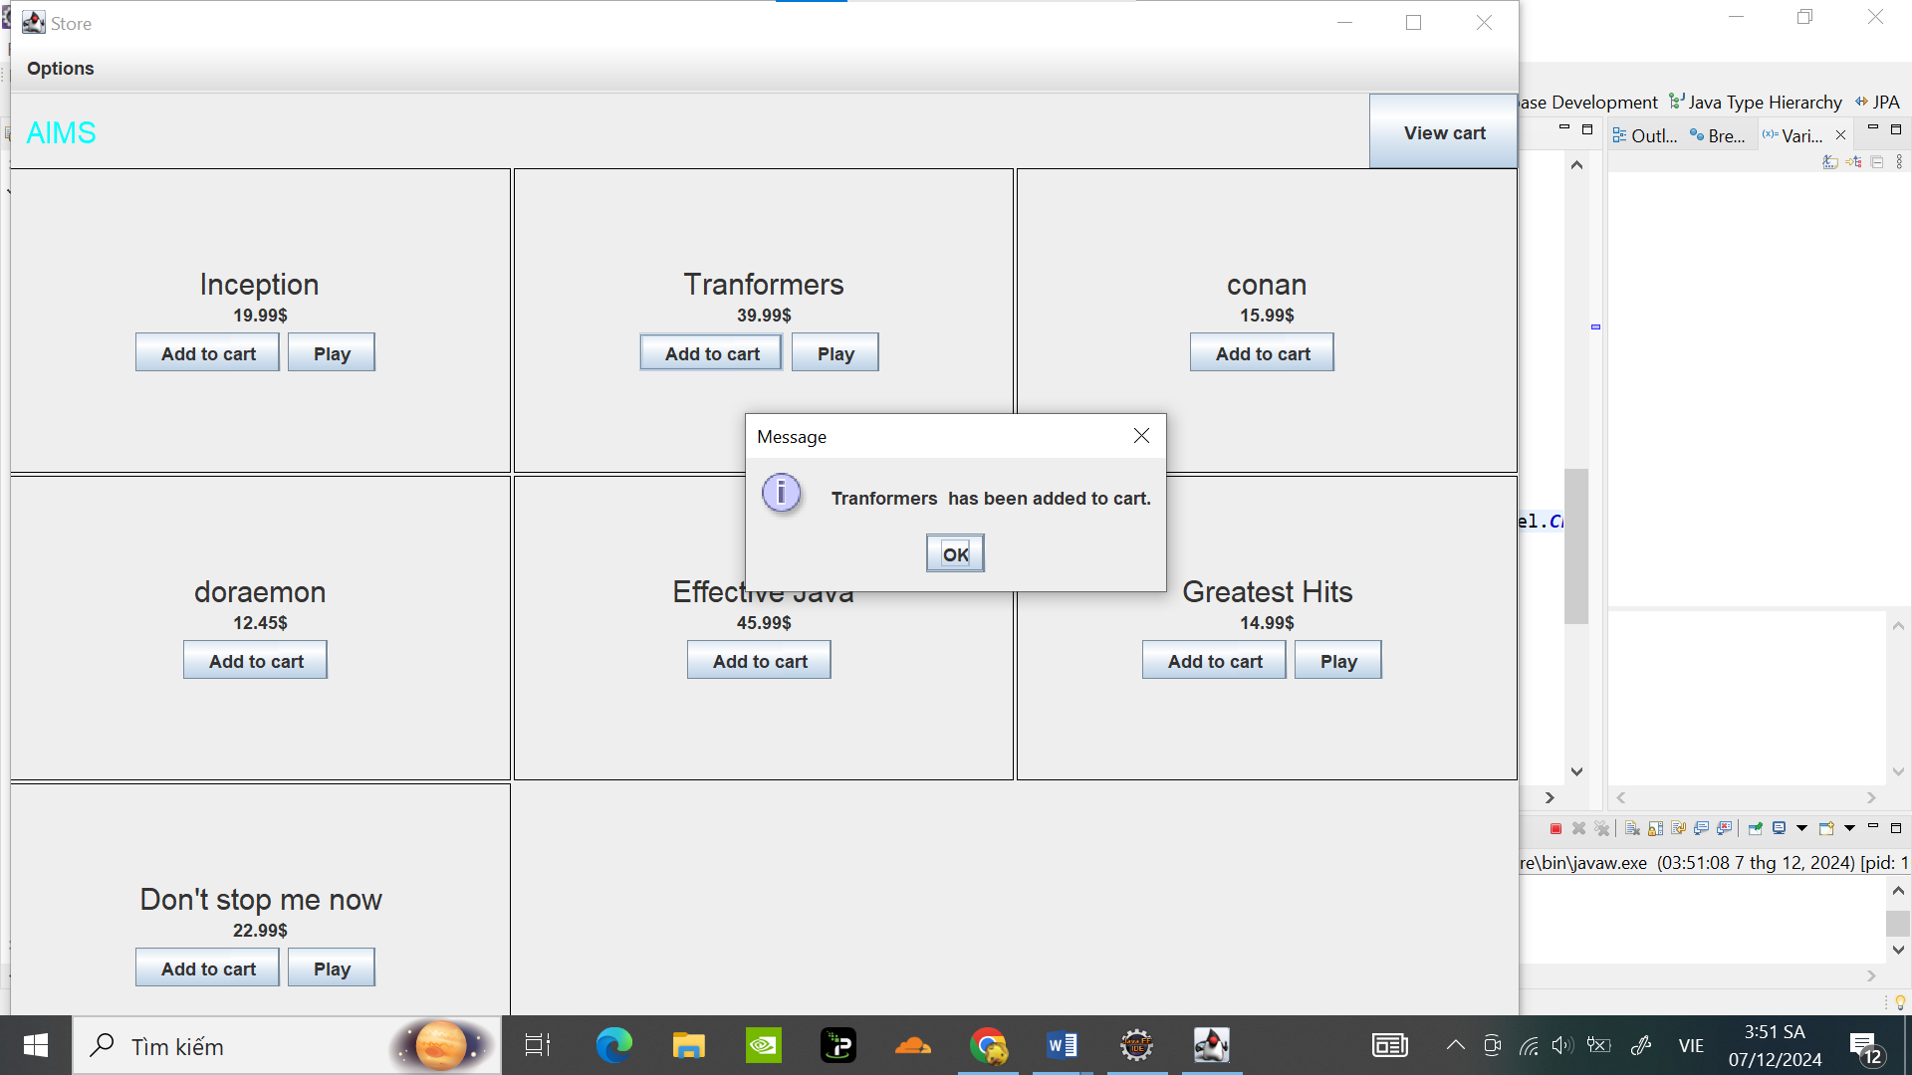

Bấm Play:

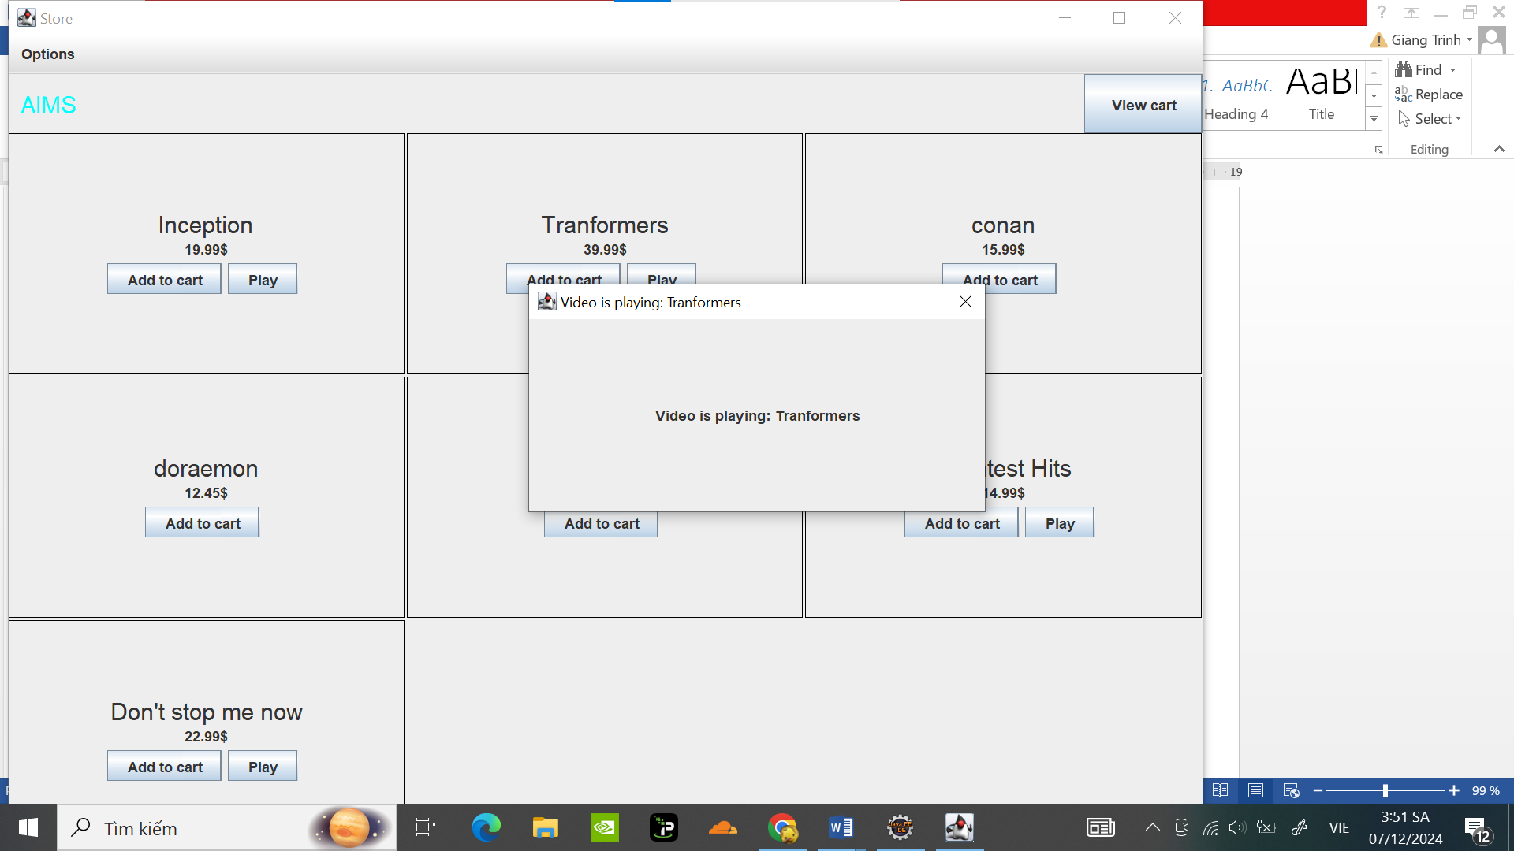

# JavaFX API

## Create the FXML file

### Create and open the FXML file in Scene Builder from Eclipse

Tạo Painter.fxml

Code:

<?xml version=*"1.0"* encoding=*"UTF-8"*?>

<?import javafx.geometry.Insets?>

<?import javafx.scene.control.Button?>

<?import javafx.scene.control.RadioButton?>

<?import javafx.scene.control.TitledPane?>

<?import javafx.scene.control.ToggleGroup?>

<?import javafx.scene.layout.BorderPane?>

<?import javafx.scene.layout.Pane?>

<?import javafx.scene.layout.VBox?>

<?import javafx.scene.text.Font?>

<BorderPane prefHeight=*"480.0"* prefWidth=*"640.0"* xmlns=*"http://javafx.com/javafx/23.0.1"* xmlns:fx=*"http://javafx.com/fxml/1"* fx:controller=*"hust.soict.dsai.javafx.PainterController"*>

<left>

<VBox maxHeight=*"1.7976931348623157E308"* spacing=*"8.0"* BorderPane.alignment=*"CENTER"*>

<children>

<TitledPane animated=*"false"* text=*"Tools"*>

<content>

<VBox prefWidth=*"100.0"* spacing=*"8.0"*>

<children>

<RadioButton mnemonicParsing=*"false"* onAction=*"#penButtonPressed"* selected=*"true"* text=*"Pen"*>

<toggleGroup>

<ToggleGroup fx:id=*"identical"* />

</toggleGroup>

</RadioButton>

<RadioButton mnemonicParsing=*"false"* onAction=*"#eraserButtonPressed"* selected=*"true"* text=*"Eraser"* toggleGroup=*"$identical"* />

</children>

</VBox>

</content>

</TitledPane>

<Button maxWidth=*"1.7976931348623157E308"* mnemonicParsing=*"false"* onAction=*"#clearButtonPressed"* text=*"Clear"*>

<font>

<Font size=*"13.0"* />

</font>

</Button>

</children>

<BorderPane.margin>

<Insets right=*"8.0"* />

</BorderPane.margin>

</VBox>

</left>

<center>

<Pane fx:id=*"drawingAreaPane"* onMouseDragged=*"#drawingAreaMouseDragged"* prefHeight=*"200.0"* prefWidth=*"200.0"* style=*"-fx-background-color: white;"* BorderPane.alignment=*"CENTER"* />

</center>

<padding>

<Insets bottom=*"8.0"* left=*"8.0"* right=*"8.0"* top=*"8.0"* />

</padding>

</BorderPane>

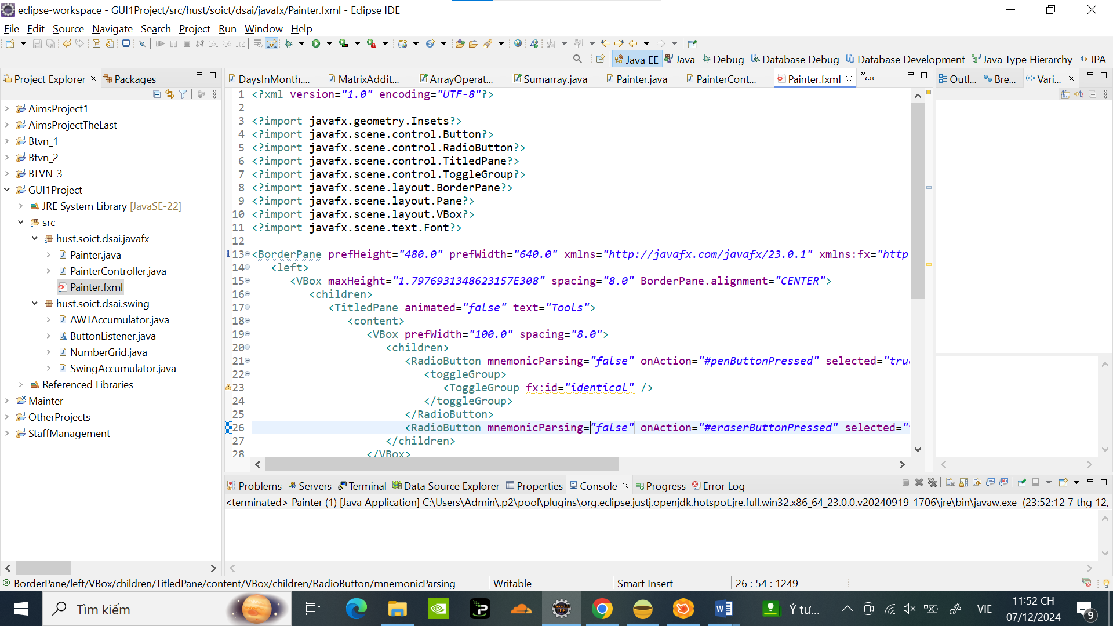

Thiết lập giao diện trong Scene Builder:

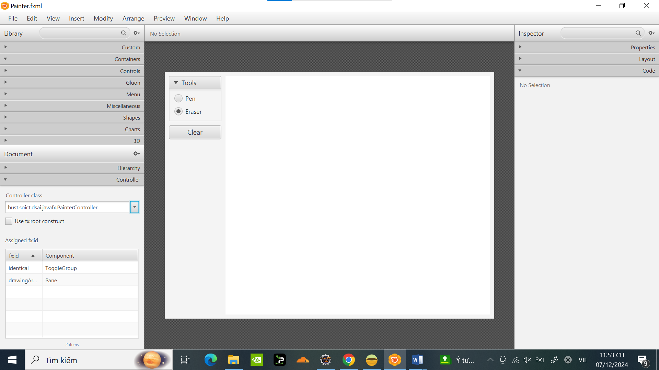

Code tạo PaintController.java:

**package** hust.soict.dsai.javafx;

**import** javafx.event.ActionEvent;

**import** javafx.fxml.FXML;

**import** javafx.scene.input.MouseEvent;

**import** javafx.scene.layout.Pane;

**import** javafx.scene.shape.Circle;

**public** **class** PainterController {

@FXML

**private** Pane drawingAreaPane;

**private** **boolean** isEraseMode = **false**; // Thêm trạng thái để kiểm tra chế độ Pen/Eraser

@FXML

**void** clearButtonPressed(ActionEvent event) {

// Xóa toàn bộ các hình trong khu vực vẽ

drawingAreaPane.getChildren().clear();

}

@FXML

**void** drawingAreaMouseDragged(MouseEvent event) {

**if** (isEraseMode) {

// Tạo một vòng tròn màu trắng để xóa (giả lập xóa bằng cách vẽ màu nền)

Circle eraserCircle = **new** Circle(event.getX(), event.getY(), 10);

eraserCircle.setFill(javafx.scene.paint.Color.***WHITE***);

drawingAreaPane.getChildren().add(eraserCircle);

} **else** {

// Tạo một vòng tròn màu đen để vẽ

Circle newCircle = **new** Circle(event.getX(), event.getY(),4);

newCircle.setFill(javafx.scene.paint.Color.***BLACK***);

drawingAreaPane.getChildren().add(newCircle);

}

}

@FXML

**void** penButtonPressed(ActionEvent event) {

// Kích hoạt chế độ vẽ

isEraseMode = **false**;

}

@FXML

**void** eraserButtonPressed(ActionEvent event) {

// Kích hoạt chế độ xóa

isEraseMode = **true**;

}

}

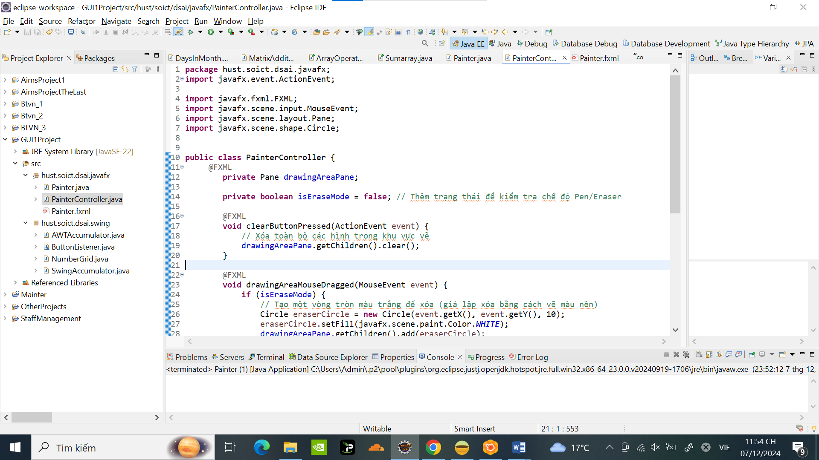

Code tạo Painter.java:

**package** hust.soict.dsai.javafx;

**import** javafx.application.Application;

**import** javafx.fxml.FXMLLoader;

**import** javafx.scene.Parent;

**import** javafx.scene.Scene;

**import** javafx.stage.Stage;

**public** **class** Painter **extends** Application {

@Override

**public** **void** start(Stage stage) **throws** Exception {

Parent root = FXMLLoader.*load*(getClass().getResource("/hust/soict/dsai/javafx/Painter.fxml"));

Scene scene = **new** Scene(root);

stage.setTitle("Painter");

stage.setScene(scene);

stage.show();

}

**public** **static** **void** main(String[] args) {

*launch*(args);

}

}

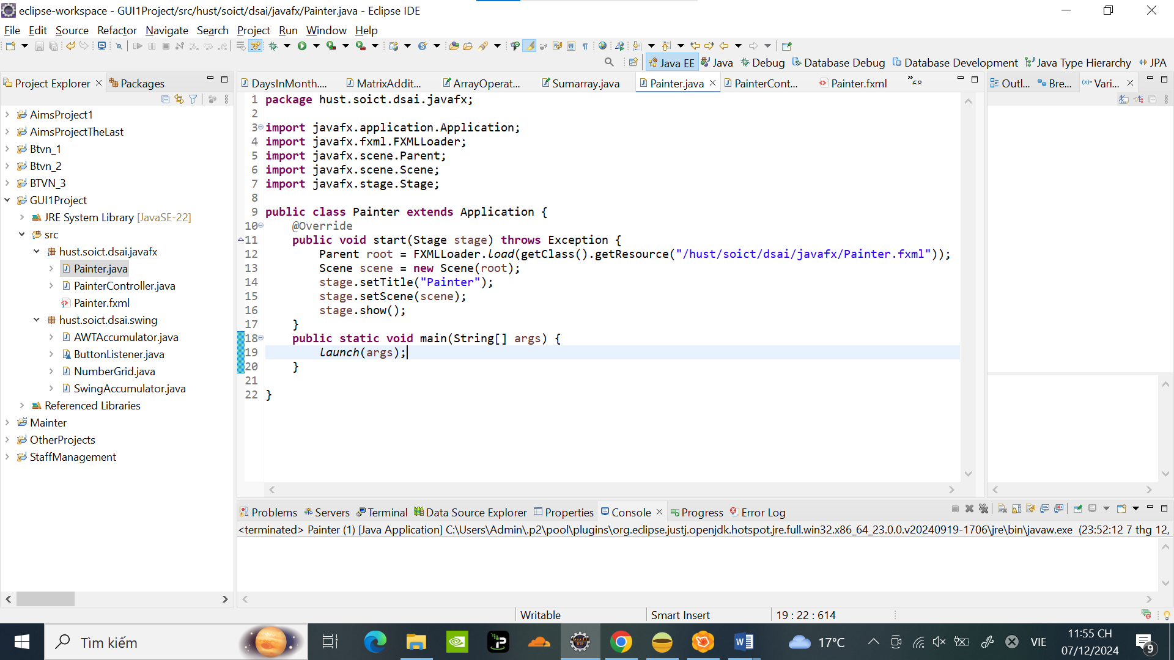

Chạy chương trình và thử vẽ j đó :

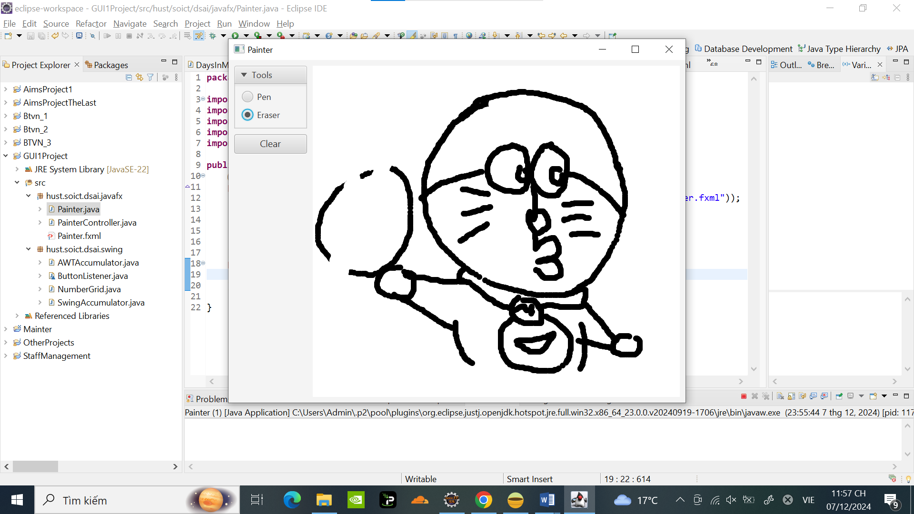

# Setting up the View Cart Screen with ScreenBuilder

Tạo Cart.fxml

Tạo Giao diện Cart bằng Scene Builder :

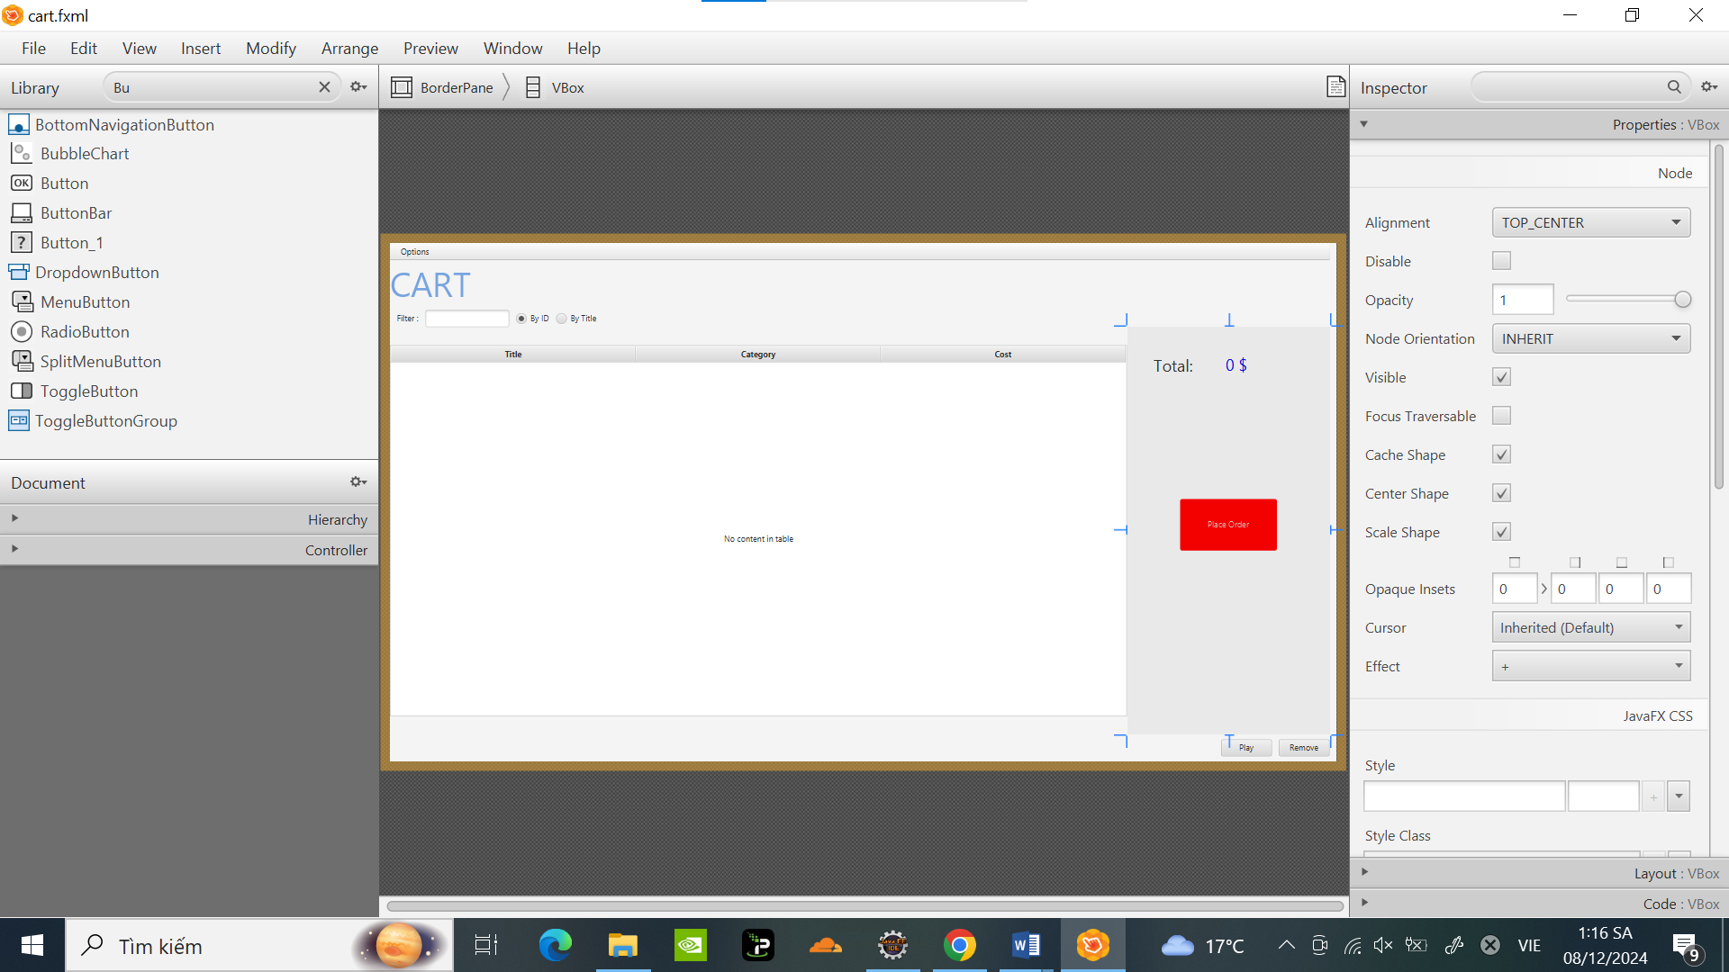

# Integrating JavaFX into Swing application – The **JFXPanel** class

Code CartScreen :

**package** hust.soict.dsai.aims.screen;

**import** java.io.IOException;

**import** java.util.ArrayList;

**import** javafx.application.Platform;

**import** javafx.embed.swing.JFXPanel;

**import** javafx.fxml.FXMLLoader;

**import** javafx.scene.Parent;

**import** javafx.scene.Scene;

**import** javax.swing.JFrame;

**import** hust.soict.dsai.aims.cart.Cart;

**import** hust.soict.dsai.aims.media.Book;

**import** hust.soict.dsai.aims.media.CompactDisc;

**import** hust.soict.dsai.aims.media.DigitalVideoDisc;

**public** **class** CartScreen **extends** JFrame {

/**

*

*/

**private** **static** **final** **long** ***serialVersionUID*** = 1L;

**private** Cart cart;

**public** CartScreen(Cart cart) {

**super**();

**this**.cart = cart;

JFXPanel fxPanel = **new** JFXPanel();

**this**.add(fxPanel);

**this**.setTitle("Cart");

**this**.setVisible(**true**);

Platform.*runLater*(**new** Runnable() {

@Override

**public** **void** run() {

**try** {

FXMLLoader loader = **new** FXMLLoader(getClass().getResource("cart.fxml"));

CartScreenController controller =

**new** CartScreenController(cart);

loader.setController(controller);

Parent root = loader.load();

fxPanel.setScene(**new** Scene(root));

} **catch** (IOException e) {

e.printStackTrace();

}

}

});

}

}

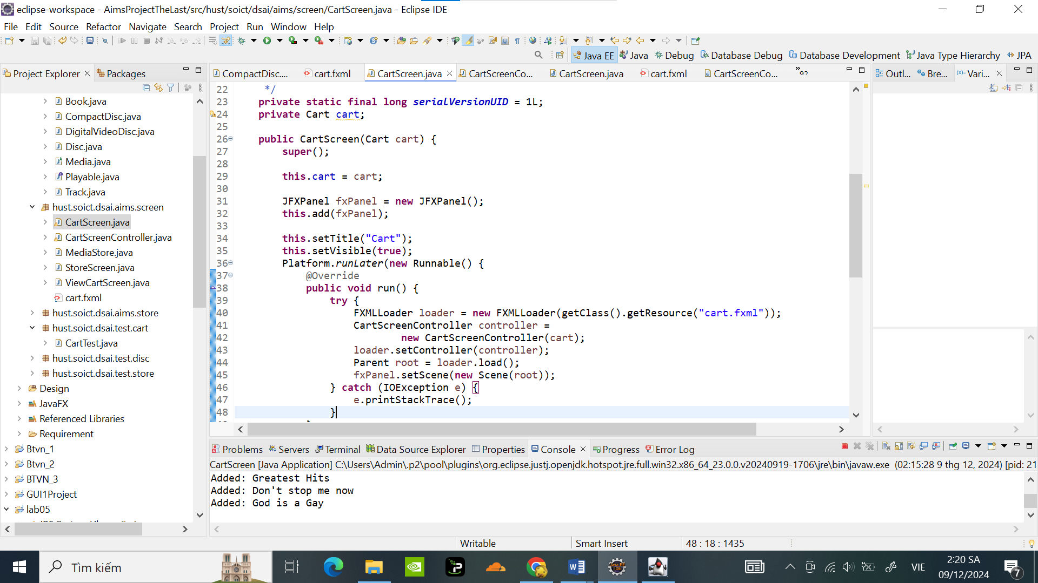

# View the items in cart – JavaFX’s data-driven UI

Code CartScreenController:

**package** hust.soict.dsai.aims.screen;

**import** hust.soict.dsai.aims.cart.Cart;

**import** hust.soict.dsai.aims.media.Media;

**import** hust.soict.dsai.aims.media.Playable;

**import** javafx.beans.value.ChangeListener;

**import** javafx.beans.value.ObservableValue;

**import** javafx.collections.FXCollections;

**import** javafx.event.ActionEvent;

**import** javafx.fxml.FXML;

**import** javafx.fxml.FXMLLoader;

**import** javafx.scene.control.*;

**import** javafx.scene.control.cell.PropertyValueFactory;

**public** **class** CartScreenController {

**private** Cart cart;

@FXML

**private** TableView<Media> tblMedia;

@FXML

**private** TableColumn<Media, String> colMediaTitle;

@FXML

**private** TableColumn<Media, String> colMediaCategory;

@FXML

**private** TableColumn<Media, Float> colMediaCost;

@FXML

**private** Button btnPlay;

@FXML

**private** Button btnRemove;

@FXML

**private** Label lbTotalCost;

**public** CartScreenController(Cart cart) {

**super**();

**this**.cart = cart;

// loader.load();

}

@FXML

**private** **void** initialize() {

colMediaTitle.setCellValueFactory(

**new** PropertyValueFactory<Media, String>("title"));

colMediaCategory.setCellValueFactory(

**new** PropertyValueFactory<Media, String>("category"));

colMediaCost.setCellValueFactory(

**new** PropertyValueFactory<Media, Float>("cost"));

tblMedia.setItems(**this**.cart.getItemsOrdered());

lbTotalCost.setText(Double.*toString*(cart.totalCost()) + " $");

btnPlay.setVisible(**false**);

btnRemove.setVisible(**false**);

tblMedia.getSelectionModel().selectedItemProperty().addListener(

**new** ChangeListener<Media>() {

@Override

**public** **void** changed(ObservableValue<? **extends** Media> observable, Media oldValue,

Media newValue) {

**if** (newValue != **null**) {

updateButtonBar(newValue);

}

}

});

}

**void** updateButtonBar(Media media){

btnRemove.setVisible(**true**);

btnPlay.setVisible(media **instanceof** Playable);

}

@FXML

**void** btnRemovePressed (ActionEvent event) **throws** Exception {

Media media = tblMedia.getSelectionModel().getSelectedItem();

cart.removeMedia(media);

lbTotalCost.setText(Double.*toString*(cart.totalCost()) + " $");

}

@FXML

**void** btnPlaceOrderPressed(ActionEvent event) {

}

@FXML

**void** btnPlayPressed(ActionEvent event) {

}

}

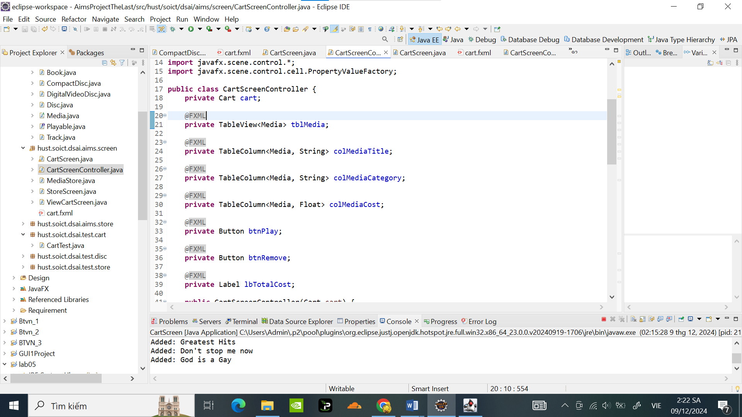

Test chương trình bằng cách viết hàm main vào CartScreen:

**public** **static** **void** main(String[] args) {

// Khởi chạy ứng dụng Swing

javax.swing.SwingUtilities.*invokeLater*(**new** Runnable() {

@Override

**public** **void** run() {

Cart cart = **new** Cart();

// Tạo các đối tượng Media

DigitalVideoDisc dvd1 = **new** DigitalVideoDisc( "Tranformers", "action", "Micheal Bay", 198, 39.99f);

DigitalVideoDisc dvd2 = **new** DigitalVideoDisc( "Inception", "Sci-Fi", "Christopher Nolan", 148, 19.99f);

DigitalVideoDisc dvd3 = **new** DigitalVideoDisc( "Ruler", "anime", "Mihazaki", 121, 11.67f);

Book book1 = **new** Book( "Effective Java", "Programming", 45.99f, **new** ArrayList<>());

Book book2 = **new** Book( "Golden Shining ", "Art ", 15.45f, **new** ArrayList<>());

CompactDisc cd1 = **new** CompactDisc("Greatest Hits", "Music","Godfather" ,134, 14.99f,"J-97");

CompactDisc cd2 = **new** CompactDisc("Don't stop me now", "Music","Mamaday" ,167, 22.99f,"hololive");

CompactDisc cd3 = **new** CompactDisc("God is a Gay", "Music","taylor" ,67, 20.9f,"live");

cart.addMedia(dvd1);

cart.addMedia(dvd2);

cart.addMedia(dvd3);

cart.addMedia(book1);

cart.addMedia(book2);

cart.addMedia(cd1);

cart.addMedia(cd2);

cart.addMedia(cd3);

**new** CartScreen(cart);

}

});

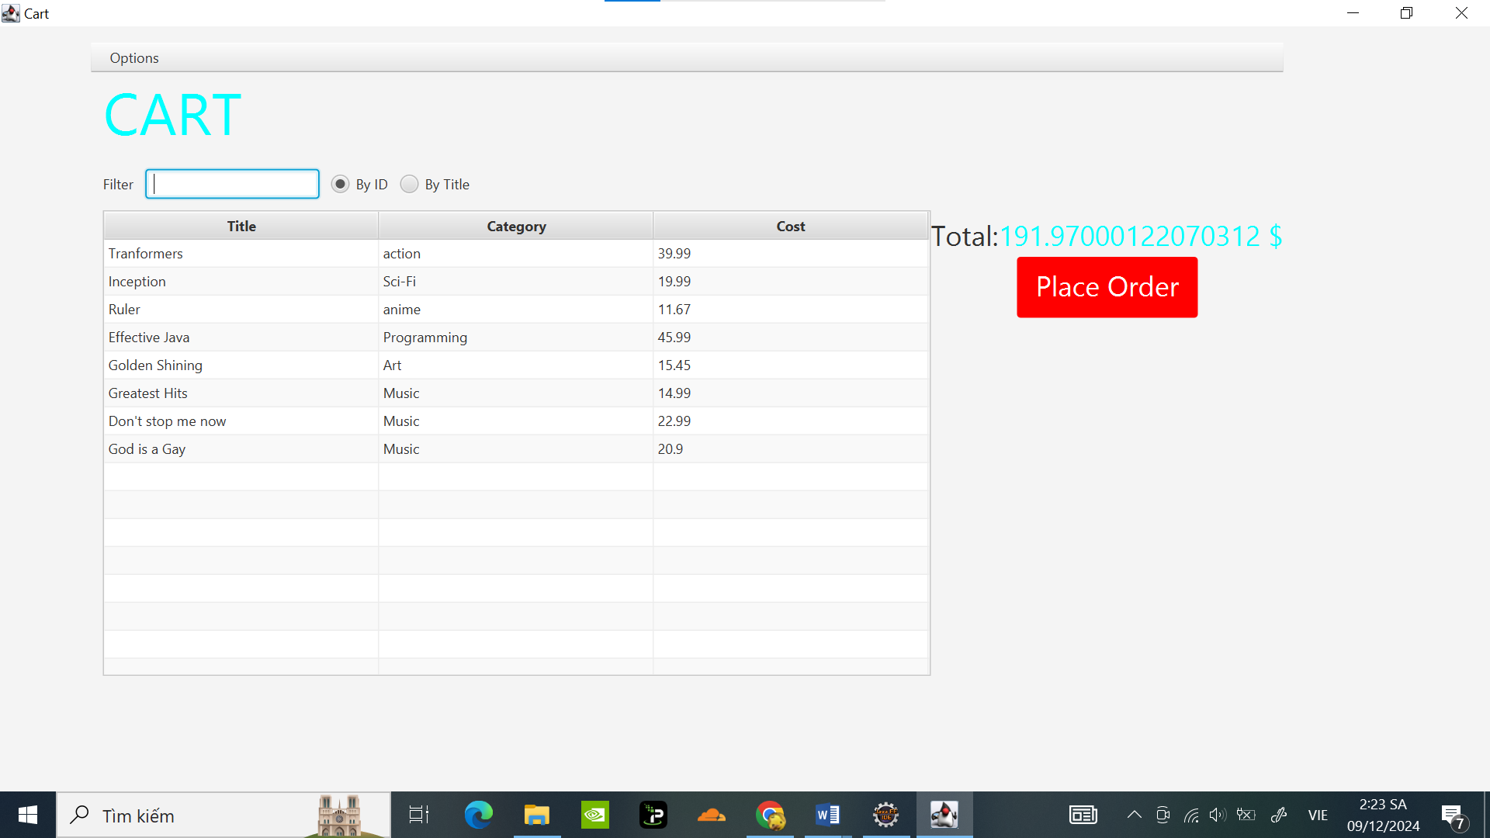

# Updating buttons based on selected item in **TableView** – **ChangeListener**

(Đã thực hiện ở đoạn Code P7 Class CartScreenController)

Test : ( Ban đầu ko có nút Play, Remove )

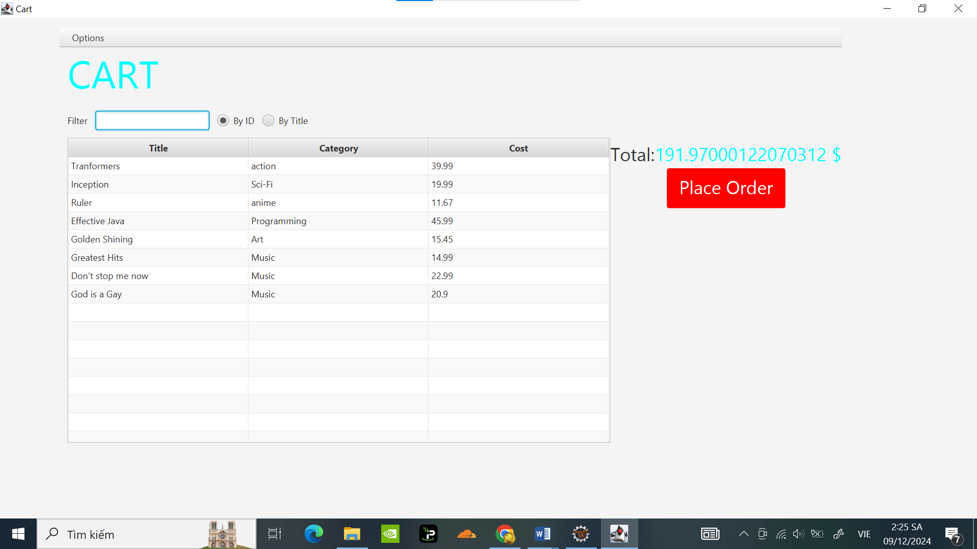

Khi bấm vào 1 Media :

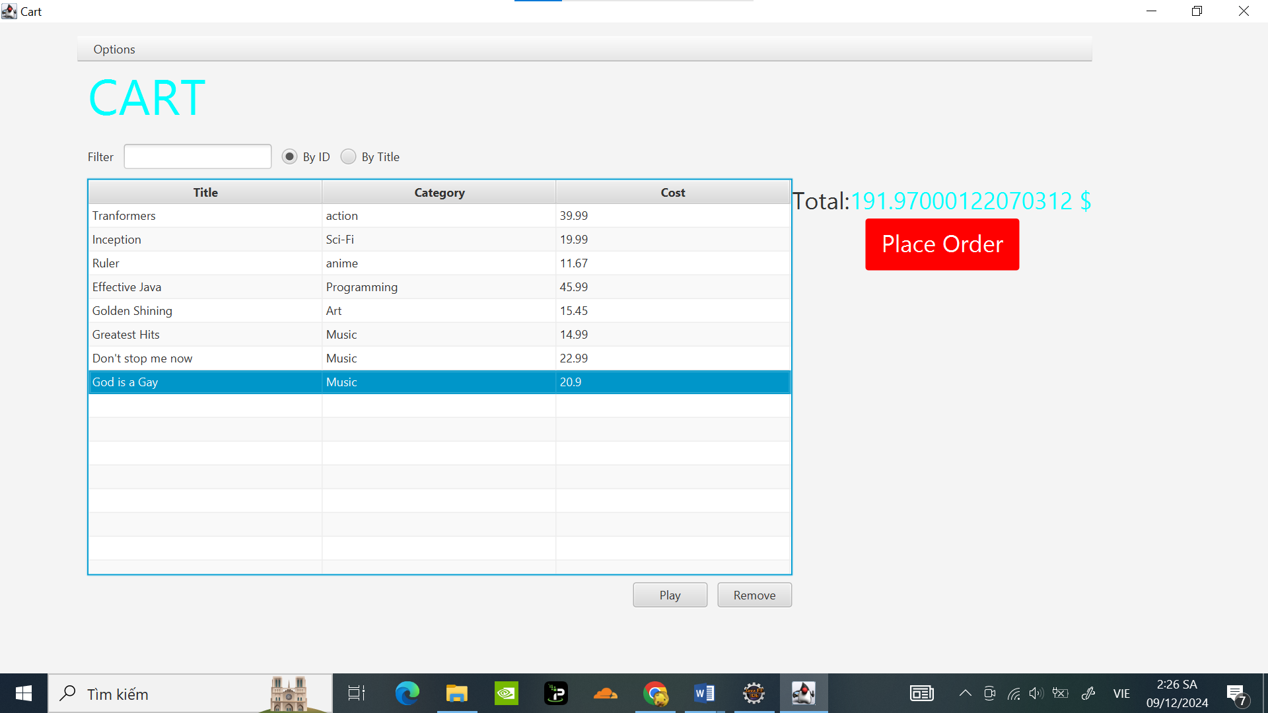

Play :

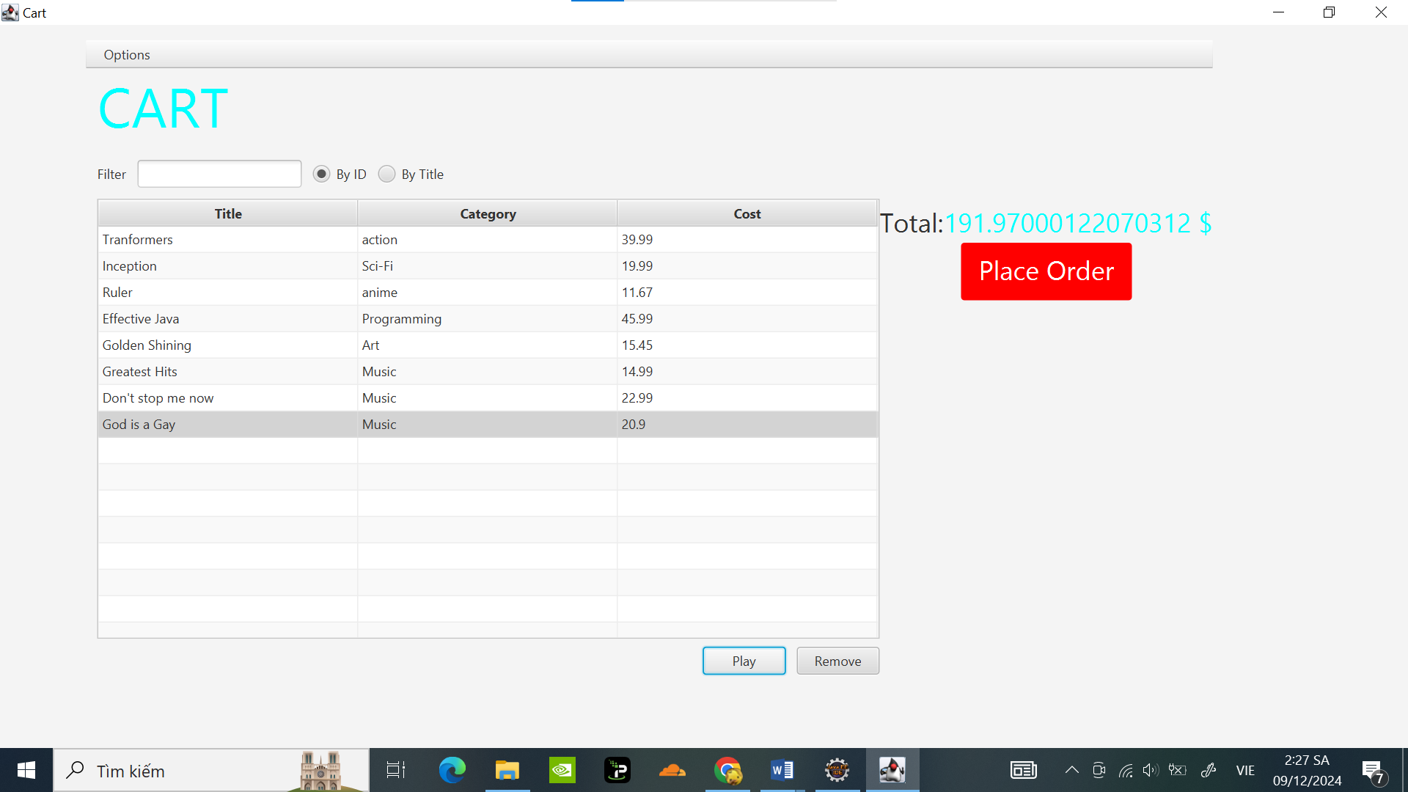

# Deleting a media

( Đã thực hiện Code ở phần 7 )

Remove : (Cập nhật lại giá tiền )

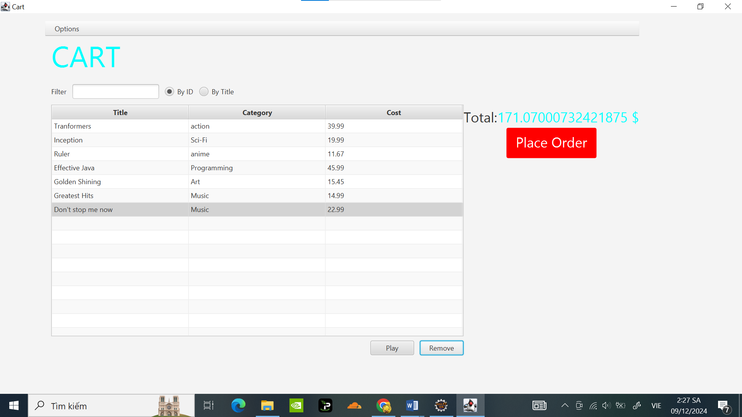

# Filter items in cart – **FilteredList**

(Phần làm thêm , Không phải làm )

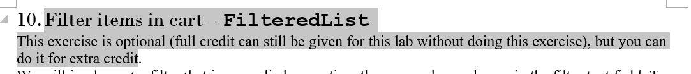

# Complete the Aims GUI application

Code update CartScreenController :

**package** hust.soict.dsai.aims.screen;

**import** javafx.collections.ObservableList;

**import** hust.soict.dsai.aims.cart.Cart;

**import** hust.soict.dsai.aims.media.Media;

**import** hust.soict.dsai.aims.media.Playable;

**import** javafx.application.Platform;

**import** javafx.beans.value.ChangeListener;

**import** javafx.beans.value.ObservableValue;

**import** javafx.collections.FXCollections;

**import** javafx.event.ActionEvent;

**import** javafx.fxml.FXML;

**import** javafx.fxml.FXMLLoader;

**import** javafx.scene.control.*;

**import** javafx.scene.control.cell.PropertyValueFactory;

**public** **class** CartScreenController {

**private** Cart cart;

@FXML

**private** TableView<Media> tblMedia;

@FXML

**private** TableColumn<Media, String> colMediaTitle;

@FXML

**private** TableColumn<Media, String> colMediaCategory;

@FXML

**private** TableColumn<Media, Float> colMediaCost;

@FXML

**private** Button btnPlay;

@FXML

**private** Button btnRemove;

@FXML

**private** Label lbTotalCost;

**public** CartScreenController(Cart cart) {

**super**();

**this**.cart = cart;

// loader.load();

}

@FXML

**private** **void** initialize() {

colMediaTitle.setCellValueFactory(

**new** PropertyValueFactory<Media, String>("title"));

colMediaCategory.setCellValueFactory(

**new** PropertyValueFactory<Media, String>("category"));

colMediaCost.setCellValueFactory(

**new** PropertyValueFactory<Media, Float>("cost"));

tblMedia.setItems(**this**.cart.getItemsOrdered());

lbTotalCost.setText(Double.*toString*(cart.totalCost()) + " $");

btnPlay.setVisible(**false**);

btnRemove.setVisible(**false**);

tblMedia.getSelectionModel().selectedItemProperty().addListener(

**new** ChangeListener<Media>() {

@Override

**public** **void** changed(ObservableValue<? **extends** Media> observable, Media oldValue,

Media newValue) {

**if** (newValue != **null**) {

updateButtonBar(newValue);

}

}

});

}

**void** updateButtonBar(Media media){

btnRemove.setVisible(**true**);

btnPlay.setVisible(media **instanceof** Playable);

}

@FXML

**void** btnRemovePressed (ActionEvent event) **throws** Exception {

Media media = tblMedia.getSelectionModel().getSelectedItem();

cart.removeMedia(media);

lbTotalCost.setText(Double.*toString*(cart.totalCost()) + " $");

}

@FXML

**void** btnPlaceOrderPressed(ActionEvent event) {

Alert alert = **new** Alert(Alert.AlertType.***INFORMATION***);

alert.setTitle("Order Confirmation");

alert.setHeaderText(**null**);

alert.setContentText("Complete Order");

alert.showAndWait();

// Xóa toàn bộ media trong giỏ hàng

cart.clear();

// Cập nhật giao diện

tblMedia.setItems(FXCollections.*observableArrayList*());

lbTotalCost.setText("0.0 $");

// Ẩn các nút vì giỏ hàng trống

btnRemove.setVisible(**false**);

btnPlay.setVisible(**false**);

}

@FXML

**void** btnPlayPressed(ActionEvent event) {

// Hiển thị thông báo video đang phát

Alert alert = **new** Alert(Alert.AlertType.***INFORMATION***);

alert.setTitle("Playing Media");

alert.setHeaderText(**null**);

alert.setContentText( "Video is playing.");

alert.showAndWait();

}

}

Code update Media Store:

package hust.soict.dsai.aims.screen;

import java.awt.Color;

import java.awt.FlowLayout;

import java.awt.Font;

import java.awt.event.ActionEvent;

import java.awt.event.ActionListener;

import javax.swing.BorderFactory;

import javax.swing.Box;

import javax.swing.BoxLayout;

import javax.swing.JButton;

import javax.swing.JDialog;

import javax.swing.JLabel;

import javax.swing.JOptionPane;

import javax.swing.JPanel;

import javax.swing.SwingUtilities;

import hust.soict.dsai.aims.cart.Cart;

import hust.soict.dsai.aims.media.Media;

import hust.soict.dsai.aims.media.Playable;

import javafx.application.Platform;

//Trinhminhdat 20225701

public class MediaStore extends JPanel {

/**

*

*/

private static final long serialVersionUID = 1L;

private Media media;

private Cart cart;

private CartScreen CartScreen;

public MediaStore(Media media,Cart cart) {

this.setMedia(media);

this.cart = cart;

this.CartScreen = CartScreen ;

setLayout(new BoxLayout(this, BoxLayout.Y_AXIS));

JLabel title = new JLabel(media.getTitle());

title.setFont(new Font(title.getFont().getName(), Font.PLAIN, 20));

title.setAlignmentX(CENTER_ALIGNMENT);

JLabel cost = new JLabel(media.getCost() + "$");

cost.setAlignmentX(CENTER_ALIGNMENT);

JPanel container = new JPanel(new FlowLayout(FlowLayout.CENTER));

JButton addToCartButton = new JButton("Add to cart");

addToCartButton.addActionListener(new ActionListener() {

@Override

public void actionPerformed(ActionEvent e) {

// Thêm media vào giỏ hàng

cart.addMedia(media);

new CartScreen(cart);

JOptionPane.showMessageDialog(null, media.getTitle() + " has been added to cart.");

}

});

container.add(addToCartButton);

if (media instanceof Playable) {

// Tạo nút "Play"

JButton playButton = new JButton("Play");

// Gán ActionListener cho nút "Play"

playButton.addActionListener(new ActionListener() {

@Override

public void actionPerformed(ActionEvent e) {

// Hiển thị media trong một cửa sổ dialog (mô phỏng phát media)

JDialog playDialog = new JDialog();

playDialog.setTitle("Video is playing: " + media.getTitle());

playDialog.setSize(400, 200);

playDialog.setLocationRelativeTo(null); // Canh giữa cửa sổ dialog

playDialog.setDefaultCloseOperation(JDialog.DISPOSE_ON_CLOSE);

// Mô phỏng việc phát media bằng cách hiển thị một thông báo

JLabel playingLabel = new JLabel("Video is playing: " + media.getTitle(), JLabel.CENTER);

playDialog.add(playingLabel);

playDialog.setVisible(true);

}

});

// Thêm nút "Play" vào container

container.add(playButton);

}

container.add(Box.createVerticalGlue());

this.add(Box.createVerticalGlue());

this.add(title);

this.add(cost);

this.add(container);

this.setBorder(BorderFactory.createLineBorder(Color.BLACK));

}

public Cart getCart() {

return cart;

}

public void setCart(Cart cart) {

this.cart = cart;

}

public Media getMedia() {

return media;

}

public void setMedia(Media media) {

this.media = media;

}

}

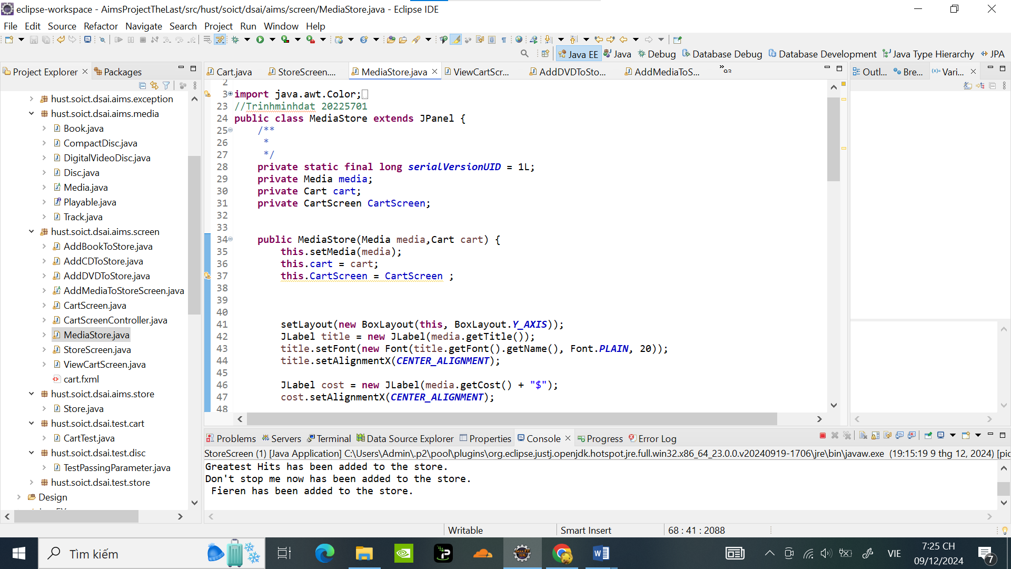

UpDate StoreScreen :

package hust.soict.dsai.aims.screen;

import java.awt.BorderLayout;

import java.awt.Color;

import java.awt.Container;

import java.awt.Dimension;

import java.awt.FlowLayout;

import java.awt.Font;

import java.awt.GridLayout;

import java.awt.event.ActionEvent;

import java.awt.event.ActionListener;

import javax.swing.Box;

import javax.swing.BoxLayout;

import javax.swing.JButton;

import javax.swing.JFrame;

import javax.swing.JLabel;

import javax.swing.JMenu;

import javax.swing.JMenuBar;

import javax.swing.JMenuItem;

import javax.swing.JPanel;

import hust.soict.dsai.aims.store.Store;

import javafx.application.Platform;

import hust.soict.dsai.aims.cart.Cart;

import hust.soict.dsai.aims.media.Book;

import hust.soict.dsai.aims.media.CompactDisc;

import hust.soict.dsai.aims.media.DigitalVideoDisc;

import hust.soict.dsai.aims.media.Media;

import java.util.ArrayList;

public class StoreScreen extends JFrame {

/**

*

*/

private static final long serialVersionUID = 1L;

private Store store;

private Cart cart;

public StoreScreen(Store store, Cart cart) {

this.store = store;

this.cart = cart;

Container cp = getContentPane();

cp.setLayout(new BorderLayout());

cp.add(createNorth(), BorderLayout.NORTH);

cp.add(createCenter(), BorderLayout.CENTER);

setVisible(true);

setTitle("Store");

setSize(1024, 768);

}

JPanel createNorth() {

JPanel north = new JPanel();

north.setLayout(new BoxLayout(north, BoxLayout.Y_AXIS));

north.add(createMenuBar());

north.add(createHeader());

return north;

}

JMenuBar createMenuBar() {

JMenu menu = new JMenu("Options");

JMenu smUpdateStore = new JMenu("Update Store");

MenuListener menuListener = new MenuListener(store, cart);

JMenuItem addBook = new JMenuItem("Add Book");

addBook.addActionListener(menuListener);

smUpdateStore.add(addBook);

JMenuItem addCD = new JMenuItem("Add CD");

addCD.addActionListener(menuListener);

smUpdateStore.add(addCD);

JMenuItem addDVD = new JMenuItem("Add DVD");

addDVD.addActionListener(menuListener);

smUpdateStore.add(addDVD);

menu.add(smUpdateStore);

JMenuItem viewStore = new JMenuItem("View store");

viewStore.addActionListener(menuListener);

menu.add(viewStore);

JMenuItem viewCart = new JMenuItem("View cart");

viewCart.addActionListener(menuListener);

menu.add(viewCart);

JMenuBar menuBar = new JMenuBar();

menuBar.setLayout(new FlowLayout(FlowLayout.LEFT));

menuBar.add(menu);

return menuBar;

}

JPanel createHeader() {

JPanel header = new JPanel();

header.setLayout(new BoxLayout(header, BoxLayout.X_AXIS));

JLabel title = new JLabel("AIMS");

title.setFont(new Font(title.getFont().getName(), Font.PLAIN, 50));

title.setForeground(Color.CYAN);

ButtonListener buttonListener = new ButtonListener(cart);

JButton cart = new JButton("View cart");

cart.setPreferredSize(new Dimension(100, 50));

cart.setMaximumSize(new Dimension(100, 50));

cart.addActionListener(buttonListener);

header.add(Box.createRigidArea(new Dimension(10, 10)));

header.add(title);

header.add(Box.createHorizontalGlue());

header.add(cart);

header.add(Box.createRigidArea(new Dimension(10, 10)));

return header;

}

JPanel createCenter() {

JPanel center = new JPanel();

center.setLayout(new GridLayout(3, 3, 2, 2));

ArrayList<Media> itemsInStore = store.getItems(); // Lấy danh sách media từ store

if (itemsInStore != null && !itemsInStore.isEmpty()) {

for (int i = 0; i < Math.min(9, itemsInStore.size()); i++) {

Media mediaItem = itemsInStore.get(i);

Cart cart = new Cart();

CartScreenController cartController = new CartScreenController(cart);

MediaStore cell = new MediaStore(mediaItem, cart); // Tạo đối tượng MediaStore

center.add(cell); // Thêm vào center panel

}

}

return center;

}

// Button Listener for View Cart

private class ButtonListener implements ActionListener {

// Attribute

private Cart cart;

// Constructor

public ButtonListener(Cart cart) {

super();

this.cart = cart;

}

@Override

public void actionPerformed(ActionEvent e) {

String button = e.getActionCommand();

if (button.equals("View cart")) {

Platform.runLater(() -> new CartScreen(cart));

setVisible(false);

dispose();

}

}

}

// Menu Listener for Menu Option

private class MenuListener implements ActionListener {

// Attribute

private Store store;

private Cart cart;

// Constructor

public MenuListener(Store store, Cart cart) {

super();

this.store = store;

this.cart = cart;

}

@Override

public void actionPerformed(ActionEvent e) {

String menu = e.getActionCommand();

if (menu.equals("Add Book")) {

new AddBookToStore(store, cart);

setVisible(false);

dispose();

} else if (menu.equals("Add CD")) {

new AddCDToStore(store, cart);

setVisible(false);

dispose();

} else if (menu.equals("Add DVD")) {

new AddDVDToStore(store, cart);

setVisible(false);

dispose();

} else if (menu.equals("View store")) {

new StoreScreen(store, cart);

setVisible(false);

dispose();

} else if (menu.equals("View cart")) {

new CartScreen(cart);

setVisible(false);

dispose();

}

}

}

public static void main(String[] args) {

Store store = new Store();

Cart cart = new Cart();

// Example media added to the store

DigitalVideoDisc dvd1 = new DigitalVideoDisc( "Inception", "Sci-Fi", "Christopher Nolan", 148, 19.99f);

DigitalVideoDisc dvd2 = new DigitalVideoDisc( "Tranformers", "action", "Micheal Bay", 198, 39.99f);

Book book1 = new Book( "conan", "anime", 15.99f, new ArrayList<>());

Book book2 = new Book( "doraemon", "anime", 12.45f, new ArrayList<>());

Book book3 = new Book( "God là tk toku Đần", "Programming", 45.99f, new ArrayList<>());

CompactDisc cd1 = new CompactDisc("Greatest Hits", "Music","Godfather" ,134, 14.99f,"J-97");

CompactDisc cd2 = new CompactDisc("Don't stop me now", "Music","Mamaday" ,167, 22.99f,"hololive");

store.addMedia(dvd1);

store.addMedia(dvd2);

store.addMedia(book1);

store.addMedia(book2);

store.addMedia(book3);

store.addMedia(cd1);

store.addMedia(cd2);

new StoreScreen(store, cart);

}

}

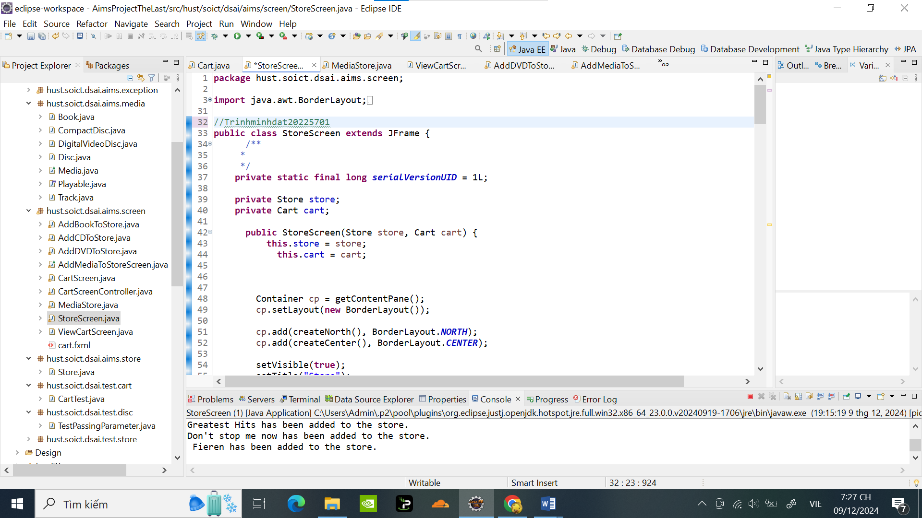

Tạo Class AddBookToStore:

package hust.soict.dsai.aims.screen;

import hust.soict.dsai.aims.cart.Cart;

import hust.soict.dsai.aims.store.Store;

import hust.soict.dsai.aims.media.Book;

import hust.soict.dsai.aims.media.CompactDisc;

import hust.soict.dsai.aims.media.DigitalVideoDisc;

import hust.soict.dsai.aims.media.Media;

import javax.swing.*;

import java.awt.*;

import java.util.Arrays;

import java.util.List;

public class AddBookToStore extends AddMediaToStoreScreen{

protected JTextField tfAuthors;

// Constructor

public AddBookToStore(Store store, Cart cart) {

super(store, cart, "Add Book to store", "ADD BOOK TO STORE");

}

JPanel createCenter() {

JPanel center = new JPanel();

tfAuthors = new JTextField(10); // TextField cho danh sách các tác giả

center.setLayout(new GridLayout(4, 2, 2, 2));

addInputRow(center, "Title", tfTitle);

addInputRow(center, "Category", tfCategory);

addInputRow(center, "Cost", tfCost);

addInputRow(center, "Authors (comma-separated)", tfAuthors); // Nhắc nhập danh sách tác giả

return center;

}

public Media createMedia() {

// Tách danh sách các tác giả từ tfAuthors

List<String> authors = Arrays.asList(tfAuthors.getText().split(","));

// Tạo đối tượng Book

return new Book(

tfTitle.getText(), // Title

tfCategory.getText(), // Category

Float.parseFloat(tfCost.getText()), // Cost

authors // Authors list

);

}

}

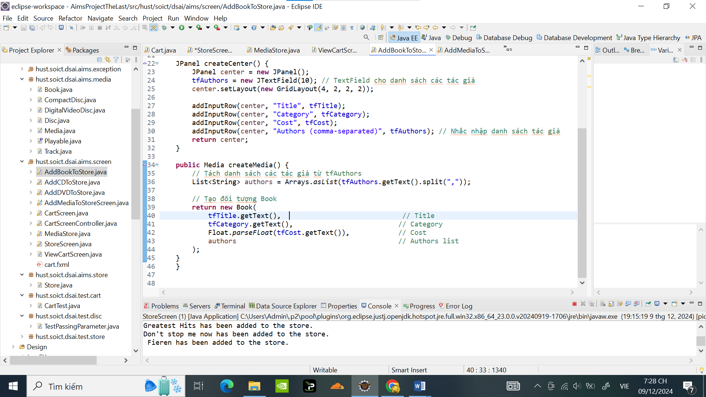

Tạo Class AddCDToStore:

package hust.soict.dsai.aims.screen;

import hust.soict.dsai.aims.cart.Cart;

import hust.soict.dsai.aims.store.Store;

import hust.soict.dsai.aims.media.Book;

import hust.soict.dsai.aims.media.CompactDisc;

import hust.soict.dsai.aims.media.DigitalVideoDisc;

import hust.soict.dsai.aims.media.Media;

import java.awt.GridLayout;

import javax.swing.JPanel;

import javax.swing.JTextField;

public class AddCDToStore extends AddMediaToStoreScreen{

// Attribute

protected JTextField tfDirector;

protected JTextField tfLength;

protected JTextField tfArtist;

// Constructor

public AddCDToStore(Store store, Cart cart) {

super(store, cart, "Add CD to store", "ADD CD TO STORE");

}

JPanel createCenter() {

JPanel center = new JPanel();

tfDirector = new JTextField(10);

tfLength = new JTextField(10);

tfArtist = new JTextField(10);

center.setLayout (new GridLayout(6, 2, 2, 2));

addInputRow(center, "Title", tfTitle);

addInputRow(center, "Category", tfCategory);

addInputRow(center, "Cost", tfCost);

addInputRow(center, "Director", tfDirector);

addInputRow(center, "Length", tfLength);

addInputRow(center, "Artist", tfArtist);

return center;

}

public Media createMedia() {

return new CompactDisc(tfTitle.getText(),

tfCategory.getText(), tfDirector.getText(),

Integer.parseInt(tfLength.getText()), Float.parseFloat(tfCost.getText()),tfArtist.getText());

}

}

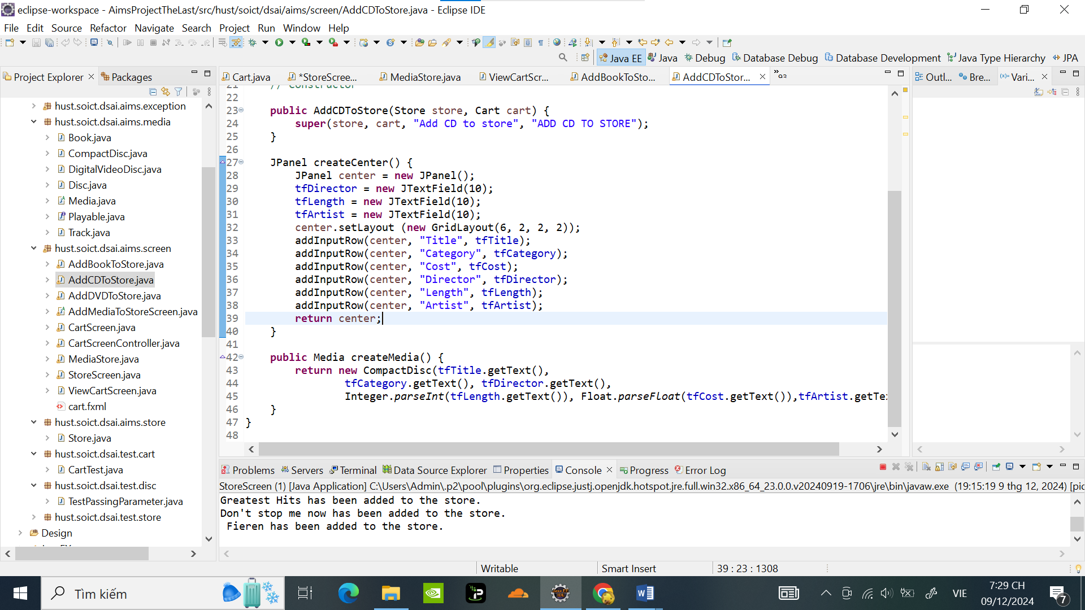

Tạo Class AddDVDToStore:

package hust.soict.dsai.aims.screen;

import hust.soict.dsai.aims.cart.Cart;

import hust.soict.dsai.aims.store.Store;

import hust.soict.dsai.aims.media.Book;

import hust.soict.dsai.aims.media.CompactDisc;

import hust.soict.dsai.aims.media.DigitalVideoDisc;

import hust.soict.dsai.aims.media.Media;

import java.awt.GridLayout;

import javax.swing.JPanel;

import javax.swing.JTextField;

public class AddDVDToStore extends AddMediaToStoreScreen{

// Attribute

protected JTextField tfDirector;

protected JTextField tfLength;

// Constructor

public AddDVDToStore(Store store, Cart cart) {

super(store, cart, "Add DVD to store", "ADD DVD TO STORE");

}

JPanel createCenter() {

JPanel center = new JPanel();

tfDirector = new JTextField(10);

tfLength = new JTextField(10);

center.setLayout (new GridLayout(5, 2, 2, 2));

addInputRow(center, "Title", tfTitle);

addInputRow(center, "Category", tfCategory);

addInputRow(center, "Director", tfDirector);

addInputRow(center, "Length", tfLength);

addInputRow(center, "Cost", tfCost);

return center;

}

public Media createMedia() {

return new DigitalVideoDisc(tfTitle.getText(),

tfCategory.getText(), tfDirector.getText(), Integer.parseInt(tfLength.getText()),

Float.parseFloat(tfCost.getText()));

}

}

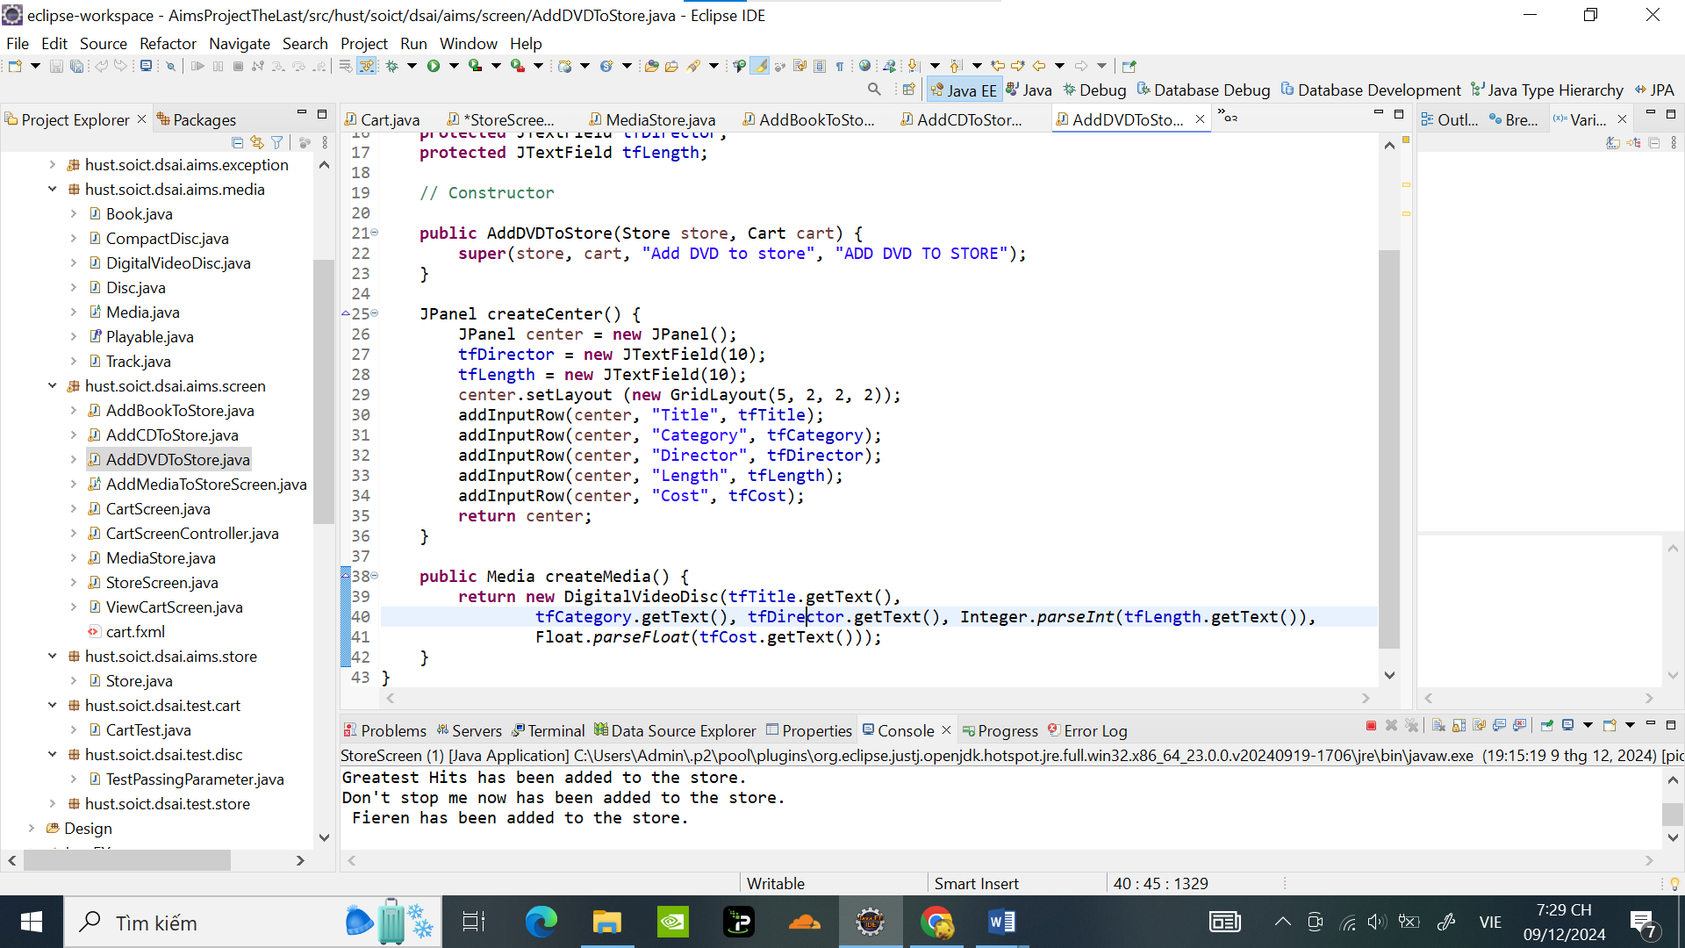

Tạo Class AddMediaToStoreScreen:

**package** hust.soict.dsai.aims.screen;

**import** java.awt.BorderLayout;

**import** java.awt.Color;

**import** java.awt.Container;

**import** java.awt.Dimension;

**import** java.awt.FlowLayout;

**import** java.awt.Font;

**import** java.awt.event.ActionEvent;

**import** java.awt.event.ActionListener;

**import** javax.swing.Box;

**import** javax.swing.BoxLayout;

**import** javax.swing.JButton;

**import** javax.swing.JFrame;

**import** javax.swing.JLabel;

**import** javax.swing.JMenu;

**import** javax.swing.JMenuBar;

**import** javax.swing.JMenuItem;

**import** javax.swing.JPanel;

**import** javax.swing.JTextField;

**import** hust.soict.dsai.aims.cart.Cart;

**import** hust.soict.dsai.aims.media.Media;

**import** hust.soict.dsai.aims.store.Store;

**public** **abstract** **class** AddMediaToStoreScreen **extends** JFrame {

// Attribute

**protected** Store store;

**protected** Cart cart;

**protected** String title = "Add media to store";

**protected** String label = "ADD MEDIA TO STORE";

**protected** JTextField tfId = **new** JTextField(10);

**protected** JTextField tfTitle = **new** JTextField(10);

**protected** JTextField tfCategory = **new** JTextField(10);

**protected** JTextField tfCost = **new** JTextField(10);

// Constructor

**public** AddMediaToStoreScreen(Store store, Cart cart, String title, String label) {

**this**.store = store;

**this**.cart = cart;

**this**.title = title;

**this**.label = label;

Container cp = getContentPane();

cp.setLayout(**new** BorderLayout());

cp.add(createCenter(), BorderLayout.***CENTER***);

cp.add(createNorth(), BorderLayout.***NORTH***);

setVisible(**true**);

setTitle(title);

setSize(1024, 768);

}

// Method to create NORTH component

JPanel createNorth() {

JPanel north = **new** JPanel();

north.setLayout(**new** BoxLayout(north, BoxLayout.***Y_AXIS***));

north.add(createMenuBar());

north.add(createHeader());

**return** north;

}

// Method to create Menu Bar

JMenuBar createMenuBar() {

JMenu menu = **new** JMenu("Options");

JMenu smUpdateStore = **new** JMenu("Update Store");

MenuListener menuListener = **new** MenuListener(store, cart);

JMenuItem addBook = **new** JMenuItem("Add Book");

addBook.addActionListener(menuListener);

smUpdateStore.add(addBook);

JMenuItem addCD = **new** JMenuItem("Add CD");

addCD.addActionListener(menuListener);

smUpdateStore.add(addCD);

JMenuItem addDVD = **new** JMenuItem("Add DVD");

addDVD.addActionListener(menuListener);

smUpdateStore.add(addDVD);

menu.add(smUpdateStore);

JMenuItem viewStore = **new** JMenuItem("View store");

viewStore.addActionListener(menuListener);

menu.add(viewStore);

JMenuItem viewCart = **new** JMenuItem("View cart");

viewCart.addActionListener(menuListener);

menu.add(viewCart);

JMenuBar menuBar = **new** JMenuBar();

menuBar.setLayout(**new** FlowLayout(FlowLayout.***LEFT***));

menuBar.add(menu);

**return** menuBar;

}

// Method to create Header

JPanel createHeader() {

JPanel header = **new** JPanel();

header.setLayout(**new** BoxLayout(header, BoxLayout.***X_AXIS***));

JLabel title = **new** JLabel(label);

title.setFont(**new** Font(title.getFont().getName(), Font.***PLAIN***, 50));

title.setForeground(Color.***CYAN***);

ButtonListener buttonListener = **new** ButtonListener(store, cart);

JButton add = **new** JButton("Add");

add.setPreferredSize(**new** Dimension(100, 50));

add.setMaximumSize(**new** Dimension(100, 50));

add.addActionListener(buttonListener);

header.add(Box.*createRigidArea*(**new** Dimension(10, 10)));

header.add(title);

header.add(Box.*createHorizontalGlue*());

header.add(add);

header.add(Box.*createRigidArea*(**new** Dimension(10, 10)));

**return** header;

}

// Method to create Center

**abstract** JPanel createCenter();

**void** addInputRow(JPanel center, String att, JTextField tf) {

JLabel l = **new** JLabel(att, JLabel.***LEFT***);

l.setLabelFor(tf);

center.add(tf);

center.add(l);

}

**public** **abstract** Media createMedia();

// Button Listener for View Cart

**private** **class** ButtonListener **implements** ActionListener {

// Attribute

**private** Store store;

**private** Cart cart;

// Constructor

**public** ButtonListener(Store store, Cart cart) {

**super**();

**this**.store = store;

**this**.cart = cart;

}

@Override

**public** **void** actionPerformed(ActionEvent e) {

String button = e.getActionCommand();

**if** (button.equals("Add")) {

Media media = createMedia();

**try** {

store.addMedia(media);

} **catch** (Exception ex) {

**throw** **new** RuntimeException(ex);

}

**new** StoreScreen(store, cart);

setVisible(**false**);

dispose();

}

}

}

// Menu Listener for Menu Option

**private** **class** MenuListener **implements** ActionListener {

// Attribute

**private** Store store;

**private** Cart cart;

// Constructor

**public** MenuListener(Store store, Cart cart) {

**super**();

**this**.store = store;

**this**.cart = cart;

}

@Override

**public** **void** actionPerformed(ActionEvent e) {

String menu = e.getActionCommand();

**if** (menu.equals("Add Book")) {

**new** AddBookToStore(store, cart);

setVisible(**false**);

dispose();

} **else** **if** (menu.equals("Add CD")) {

**new** AddCDToStore(store, cart);

setVisible(**false**);

dispose();

} **else** **if** (menu.equals("Add DVD")) {

**new** AddDVDToStore(store, cart);

setVisible(**false**);

dispose();

} **else** **if** (menu.equals("View store")) {

**new** StoreScreen(store, cart);

setVisible(**false**);

dispose();

} **else** **if** (menu.equals("View cart")) {

**new** CartScreen(cart);

setVisible(**false**);

dispose();

}

}

}

}

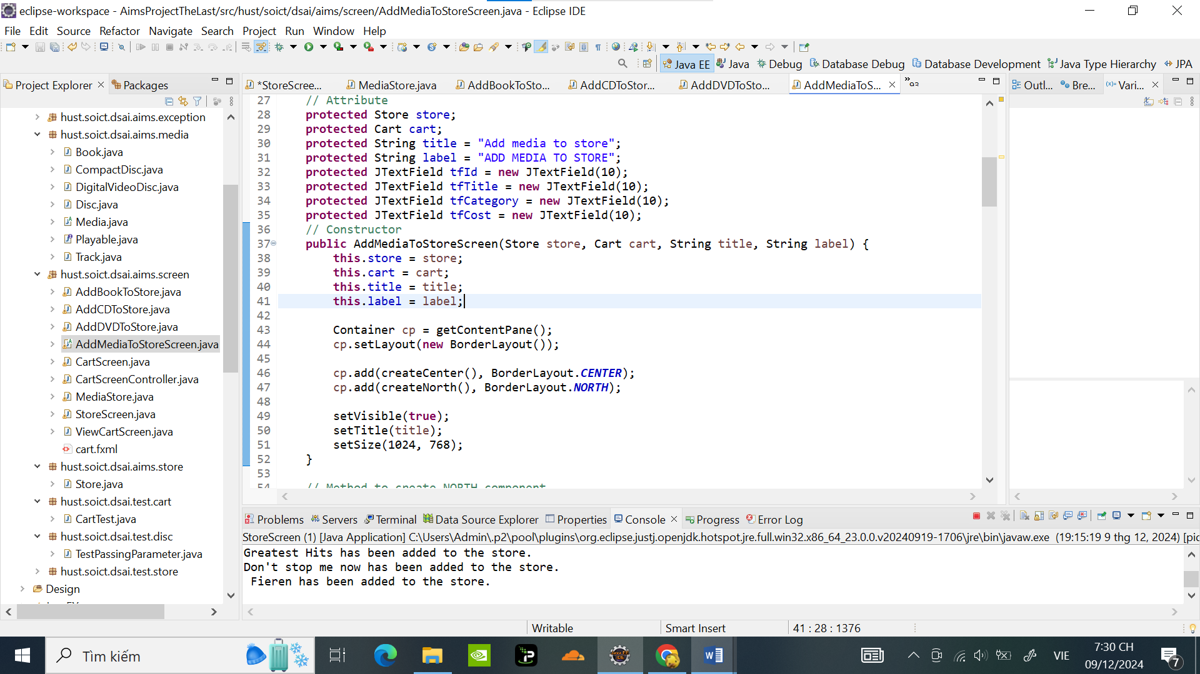

Kết quả khi chạy chương trình :

Khi thêm 1 video vào giỏ hàng:

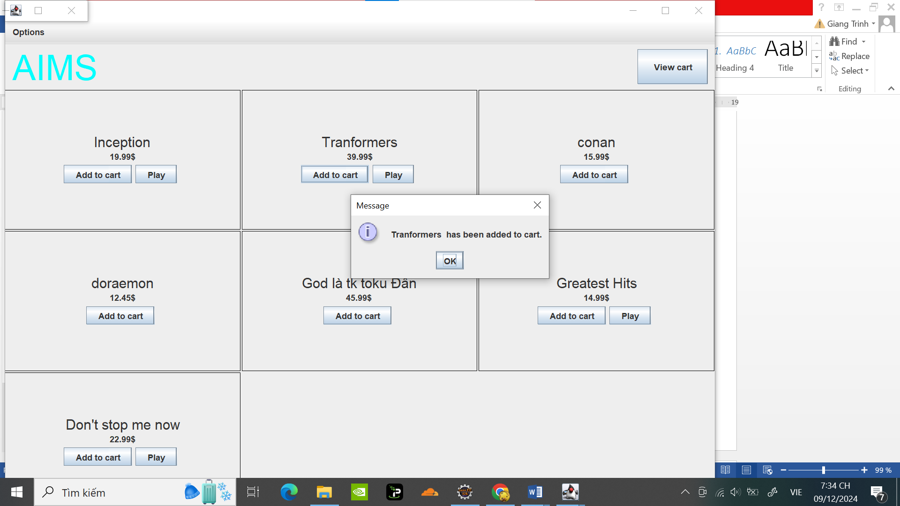

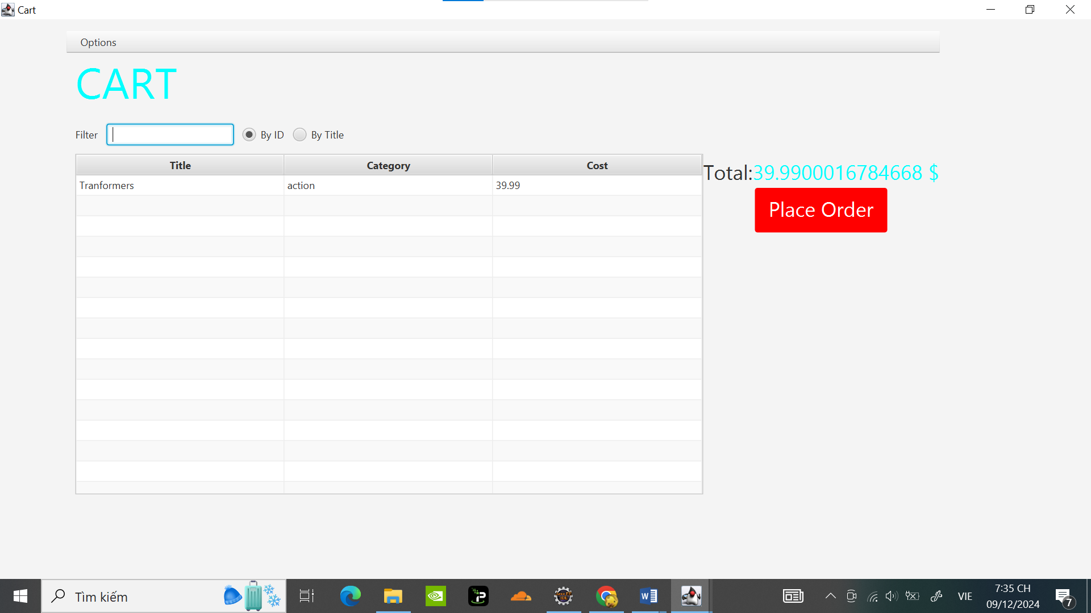

Thêm 1 DVD vào store:

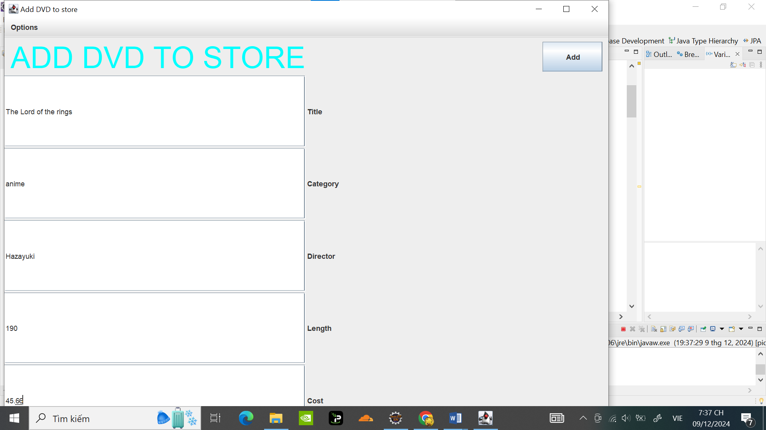

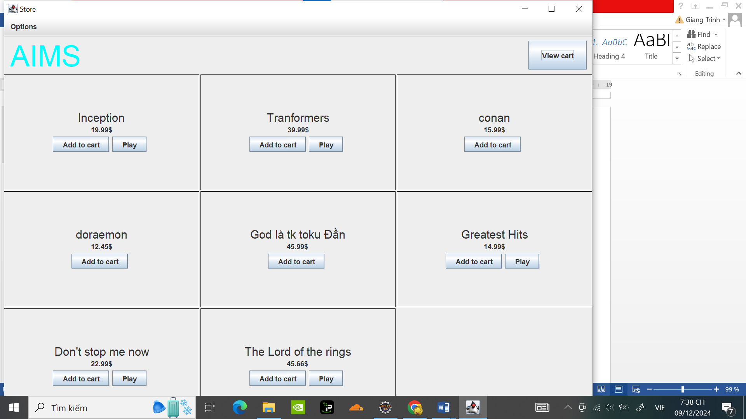

Trong Giỏ hàng bấm play:

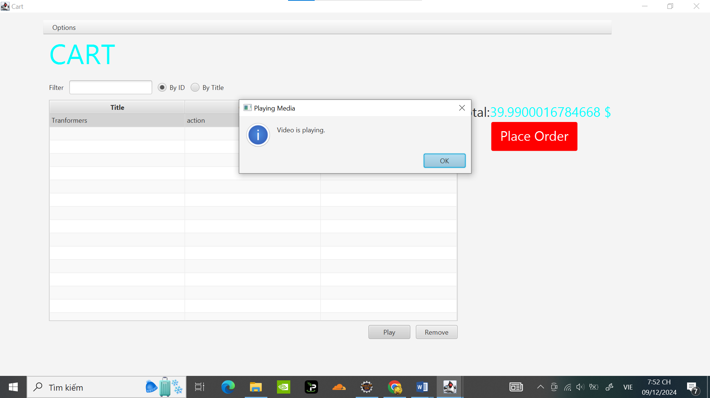

Bâm Place Order , hoàn tất đơn hàng:

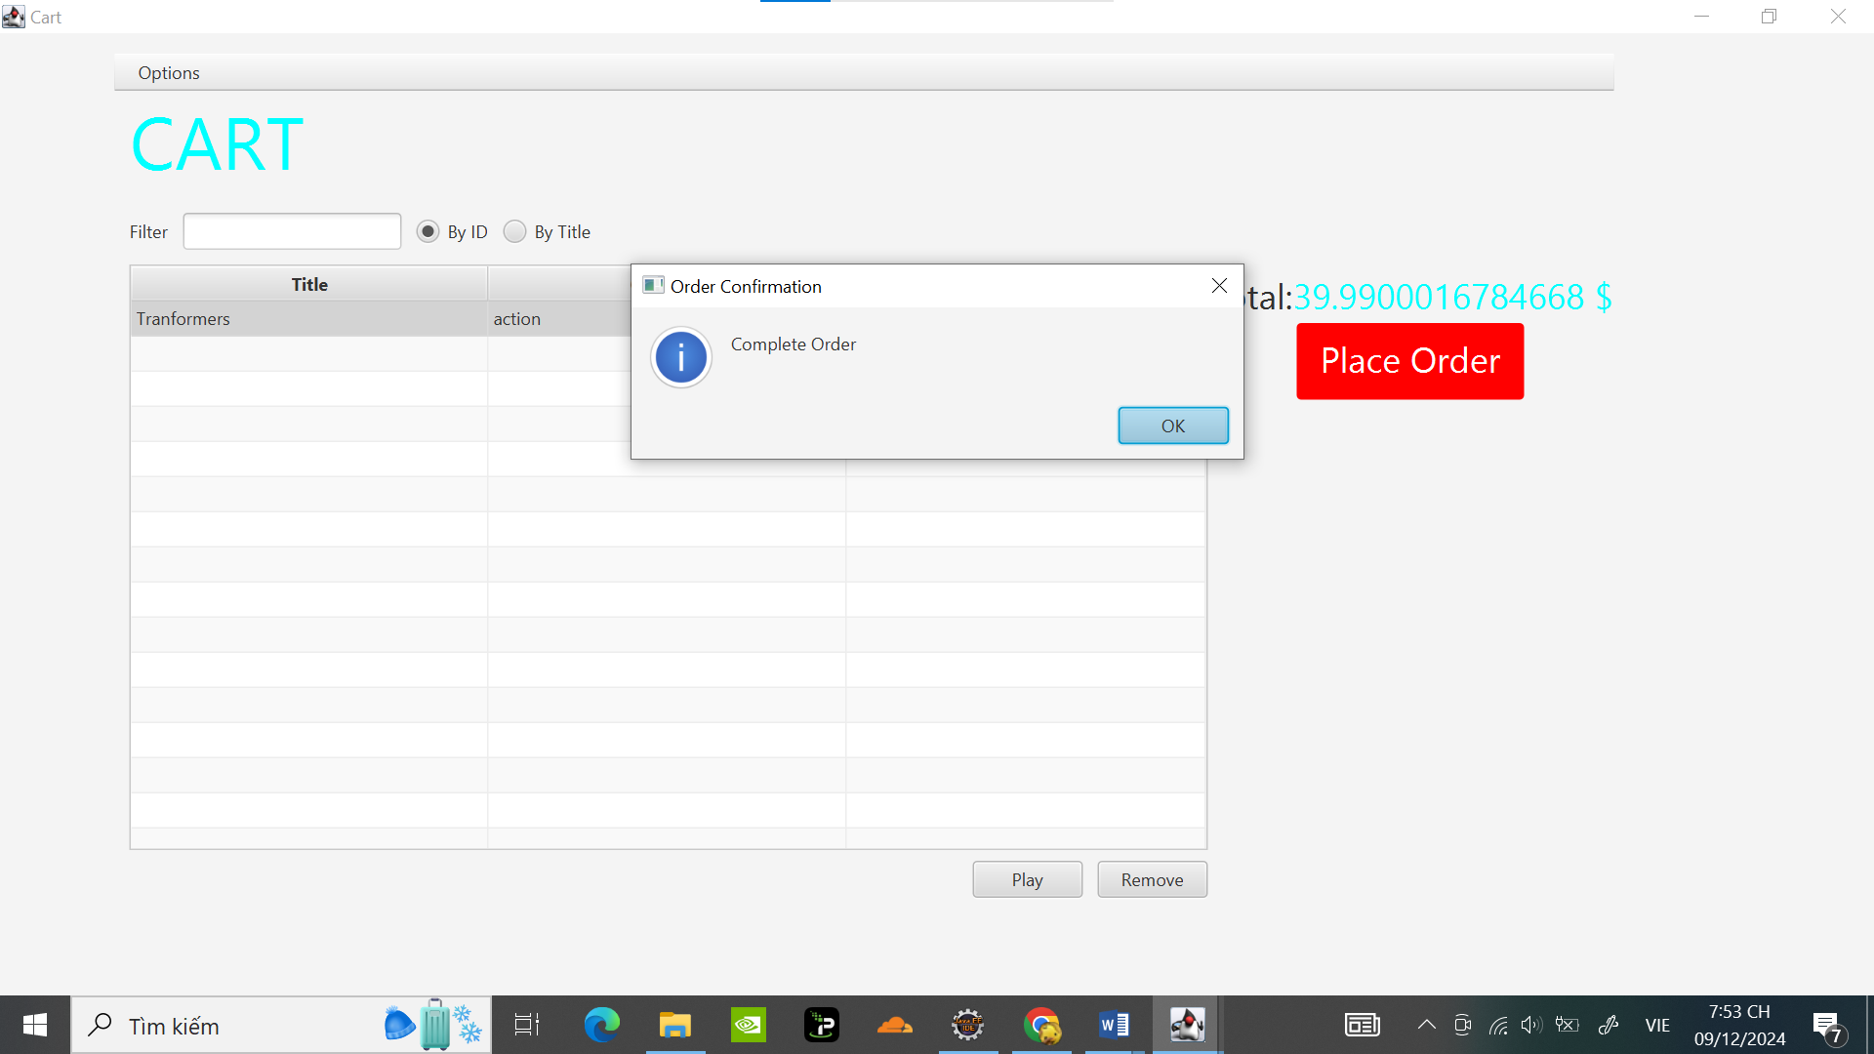

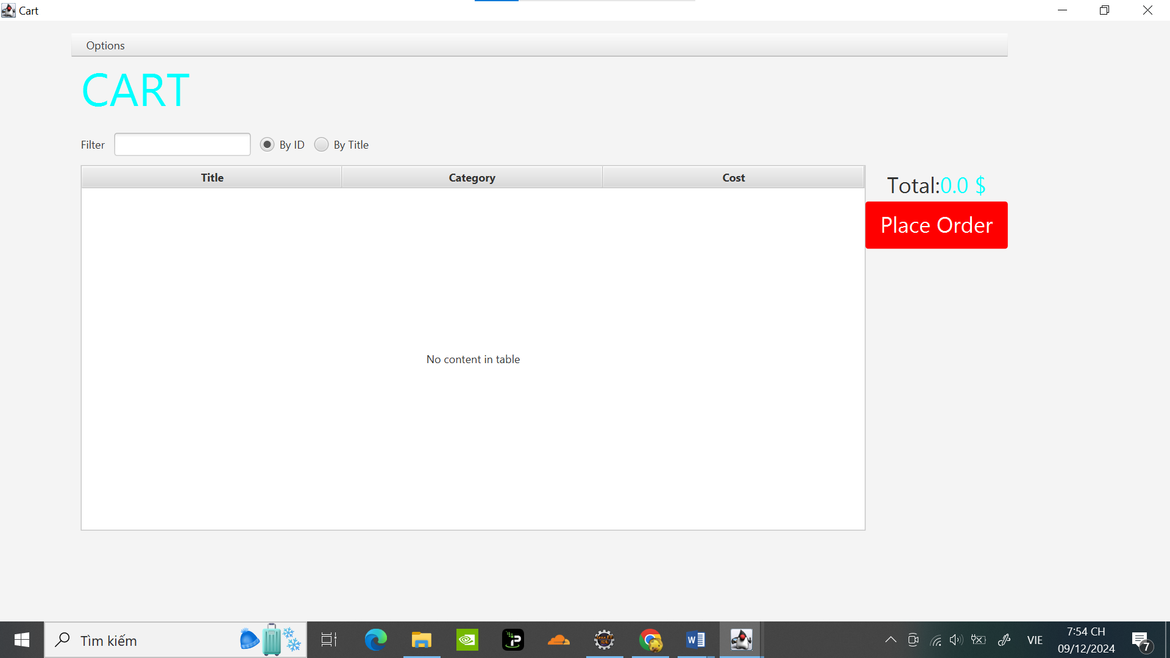

# Check all the previous source codes to catch/handle/delegate runtime exceptions

Sửa trong Cart:

**public** **void** addMedia(Media media) {

**final** **int** MAX_NUMBERS_ORDERED = 4; // Giới hạn số lượng media

**if** (media != **null**) {

**if** (itemsOrdered.size() < MAX_NUMBERS_ORDERED) {

itemsOrdered.add(media);

System.***out***.println("Added: " + media.getTitle());

} **else** {

javax.swing.JOptionPane.*showMessageDialog*(**null**,

"ERROR: The number of media has reached its limit.",

"Error",

javax.swing.JOptionPane.***ERROR_MESSAGE***);

}

} **else** {

javax.swing.JOptionPane.*showMessageDialog*(**null**,

"Cannot add a null item.",

"Warning",

javax.swing.JOptionPane.***WARNING_MESSAGE***);

}

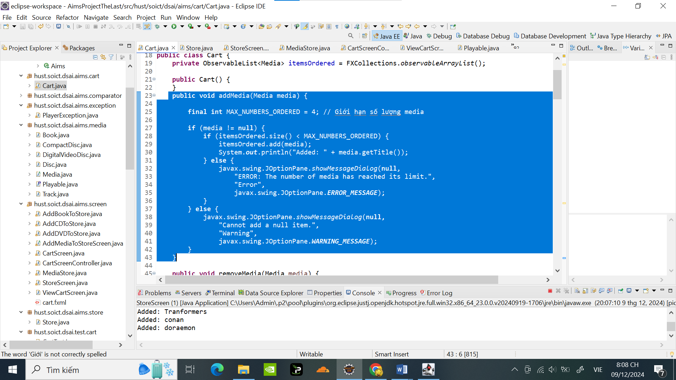

Khi add quá 4 :

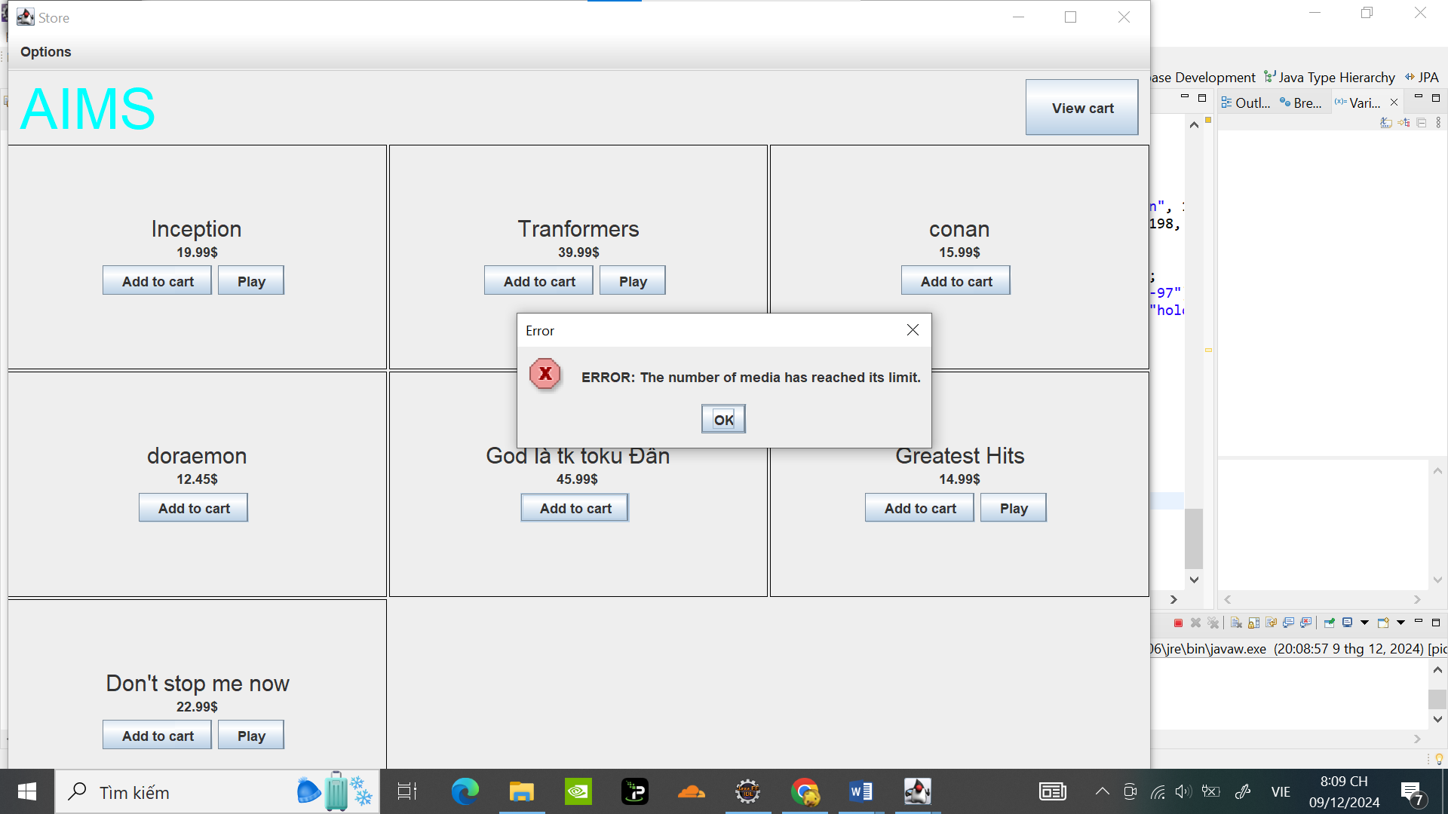

# Create a class which inherits from **Exception**

Tạo Class PlayerException :

**package** hust.soict.dsai.aims.exception;

**public** **class** PlayerException **extends** Exception{

**private** String description;

**public** PlayerException(String description) {

**this**.description = description;

}

@Override

**public** String getMessage() {

**return** description;

}

}

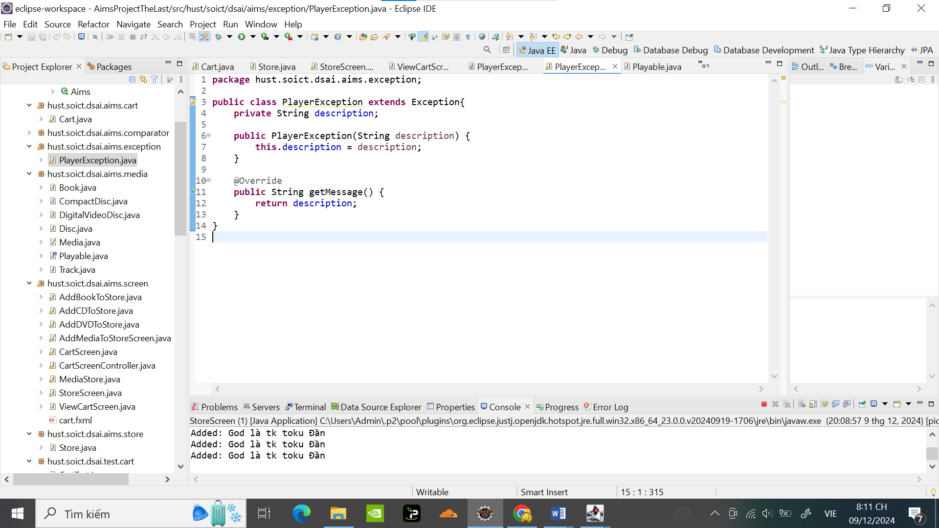

Update Playable:

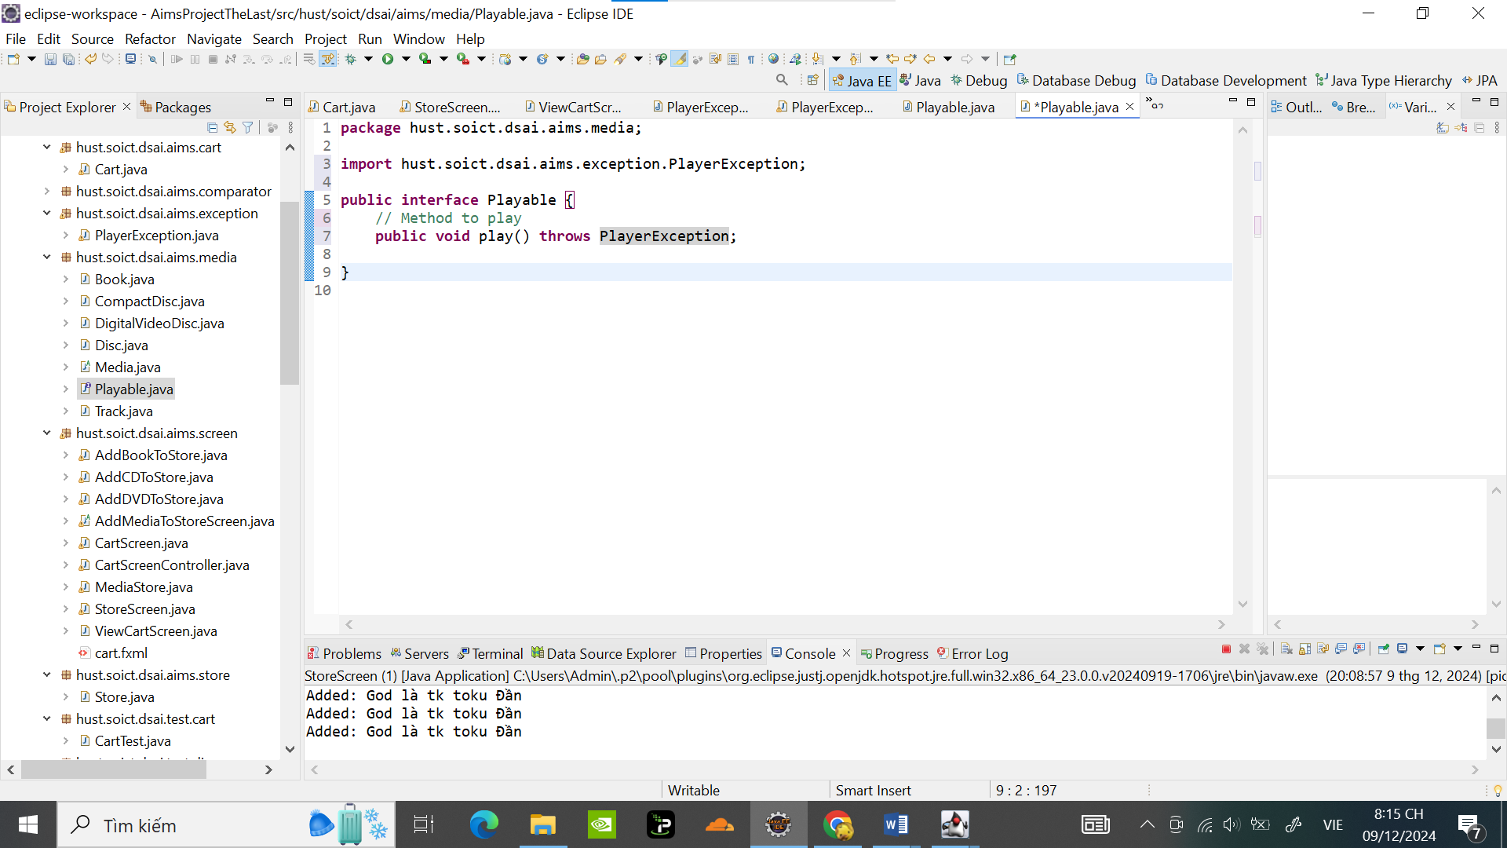

Cập nhật trong CompactDisc:

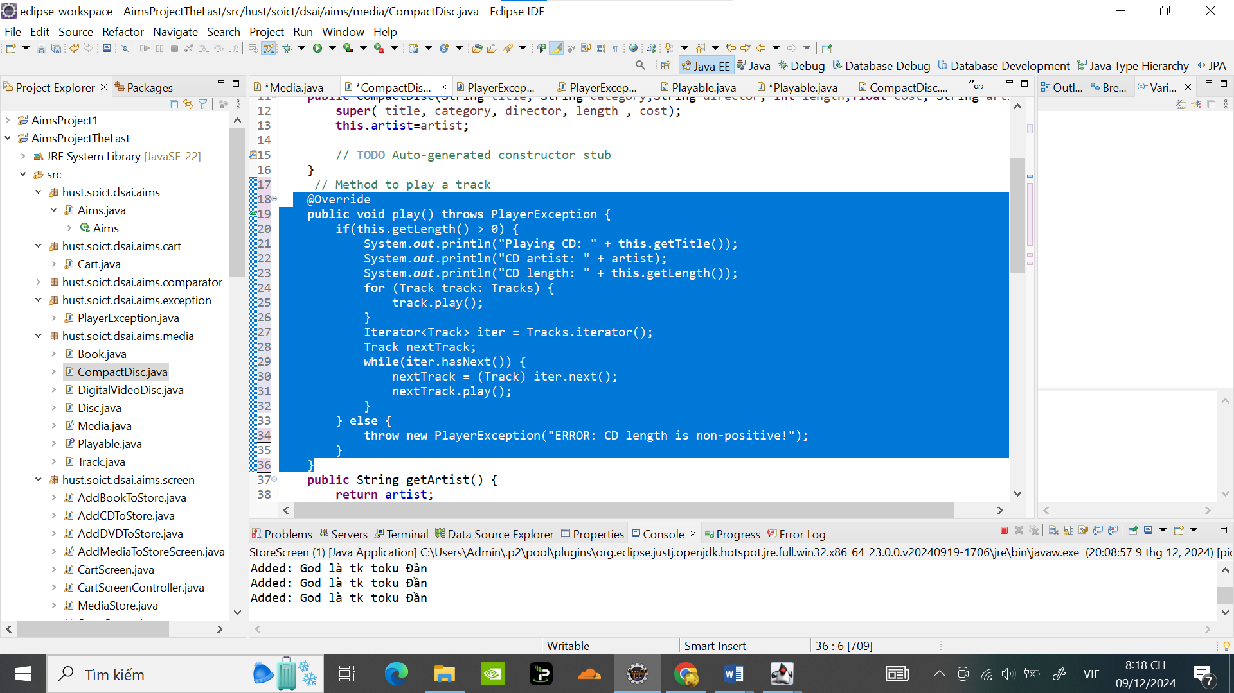

Trong DigitalVideoDisc:

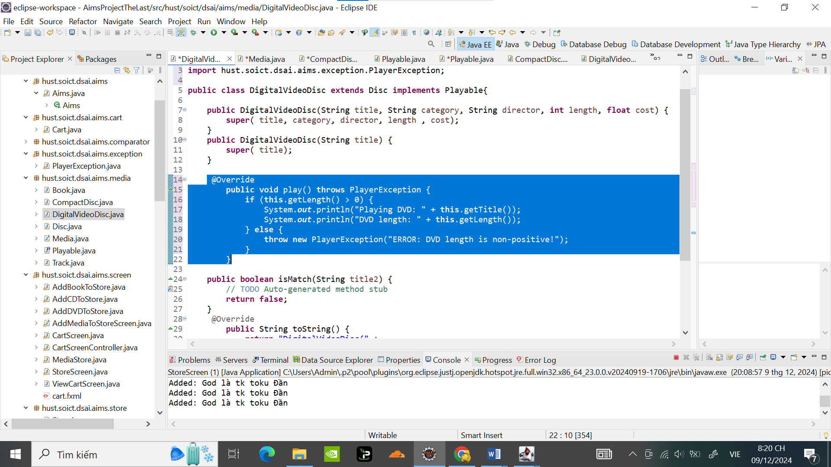

Trong Tracks :

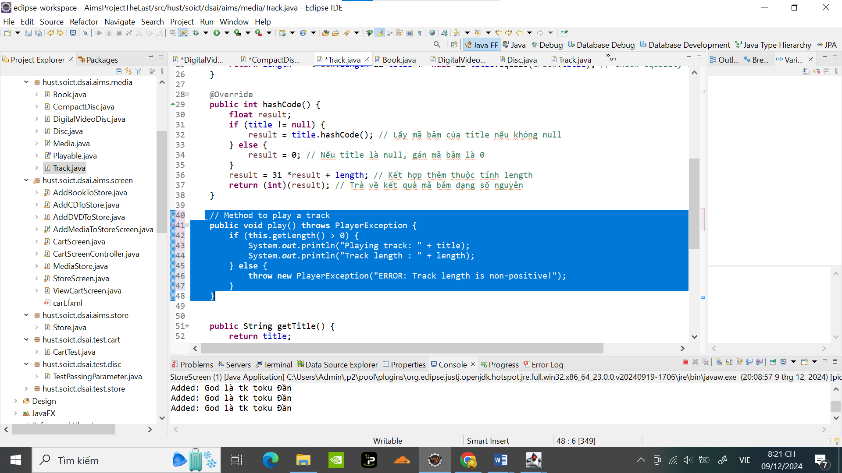

# Update the **Aims** class

Khi length <=-1 bắt lỗi :

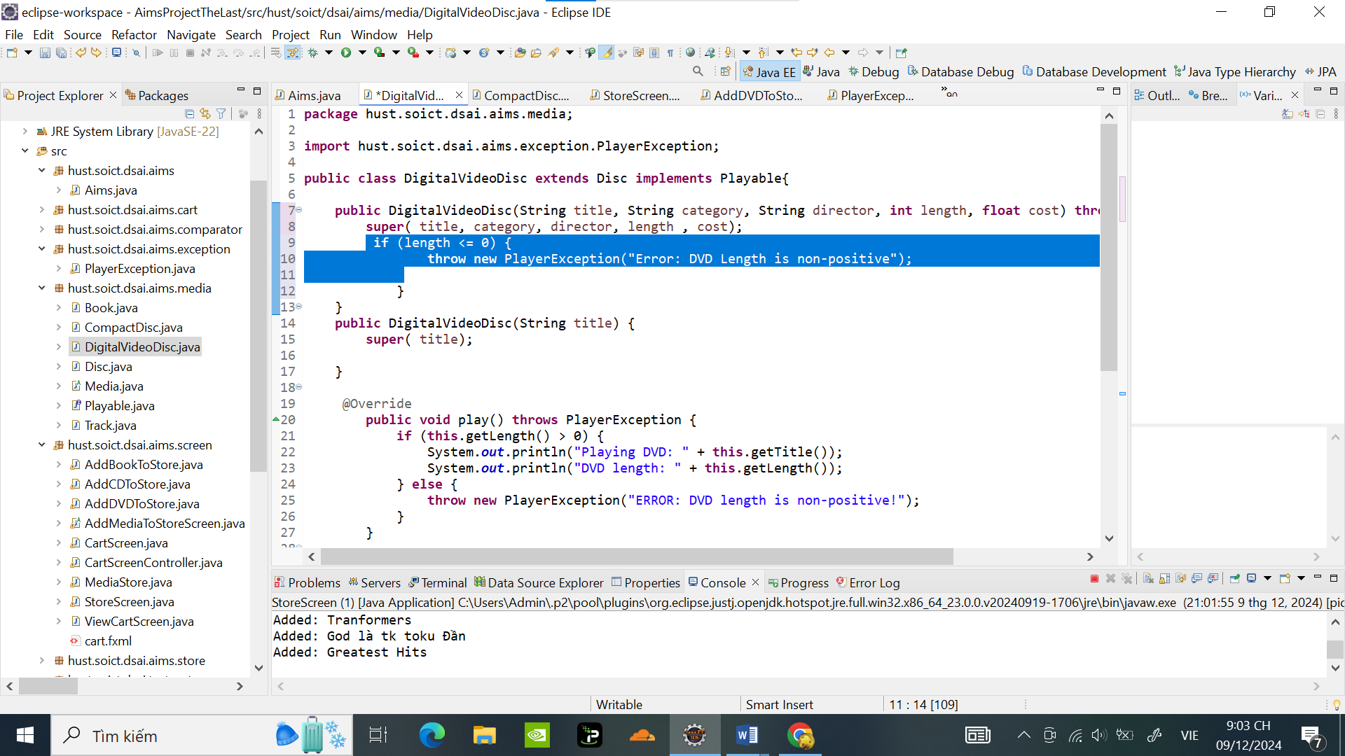

Thêm các phương thức hiển thị thông báo lỗi khi length=-1 dùng try/catch :

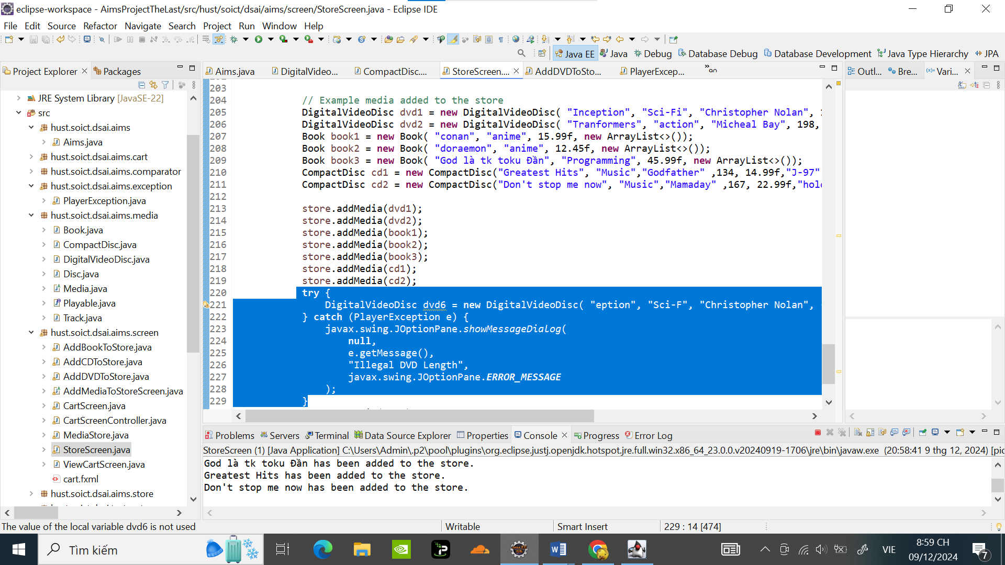

Kết quả hiển thị lỗi ngoại lệ

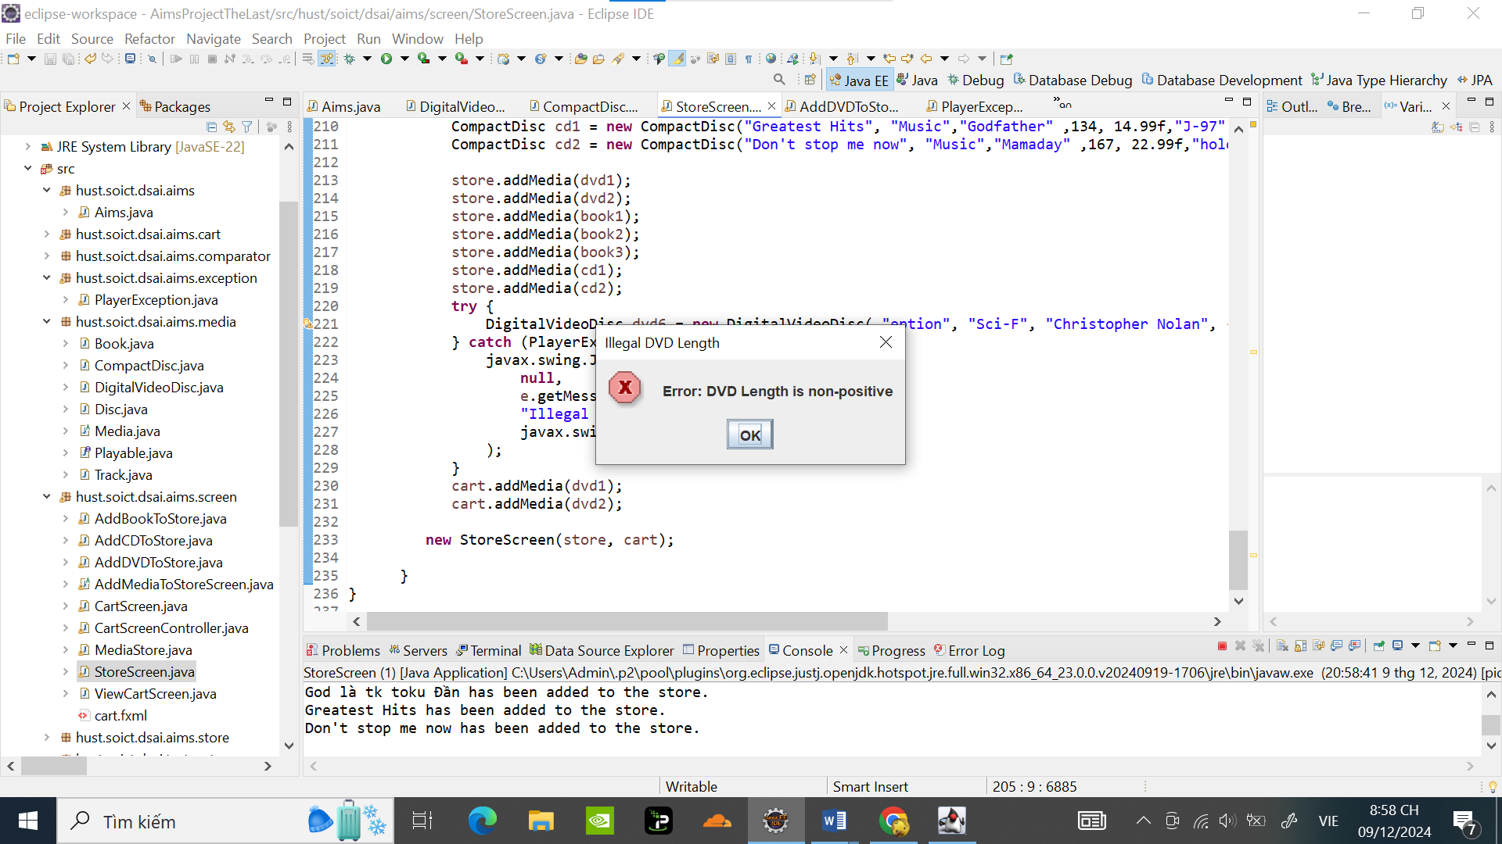

# Modify the **equals()** method of **Media** class

Check 2 Media bị trùng khi thêm Media vào :

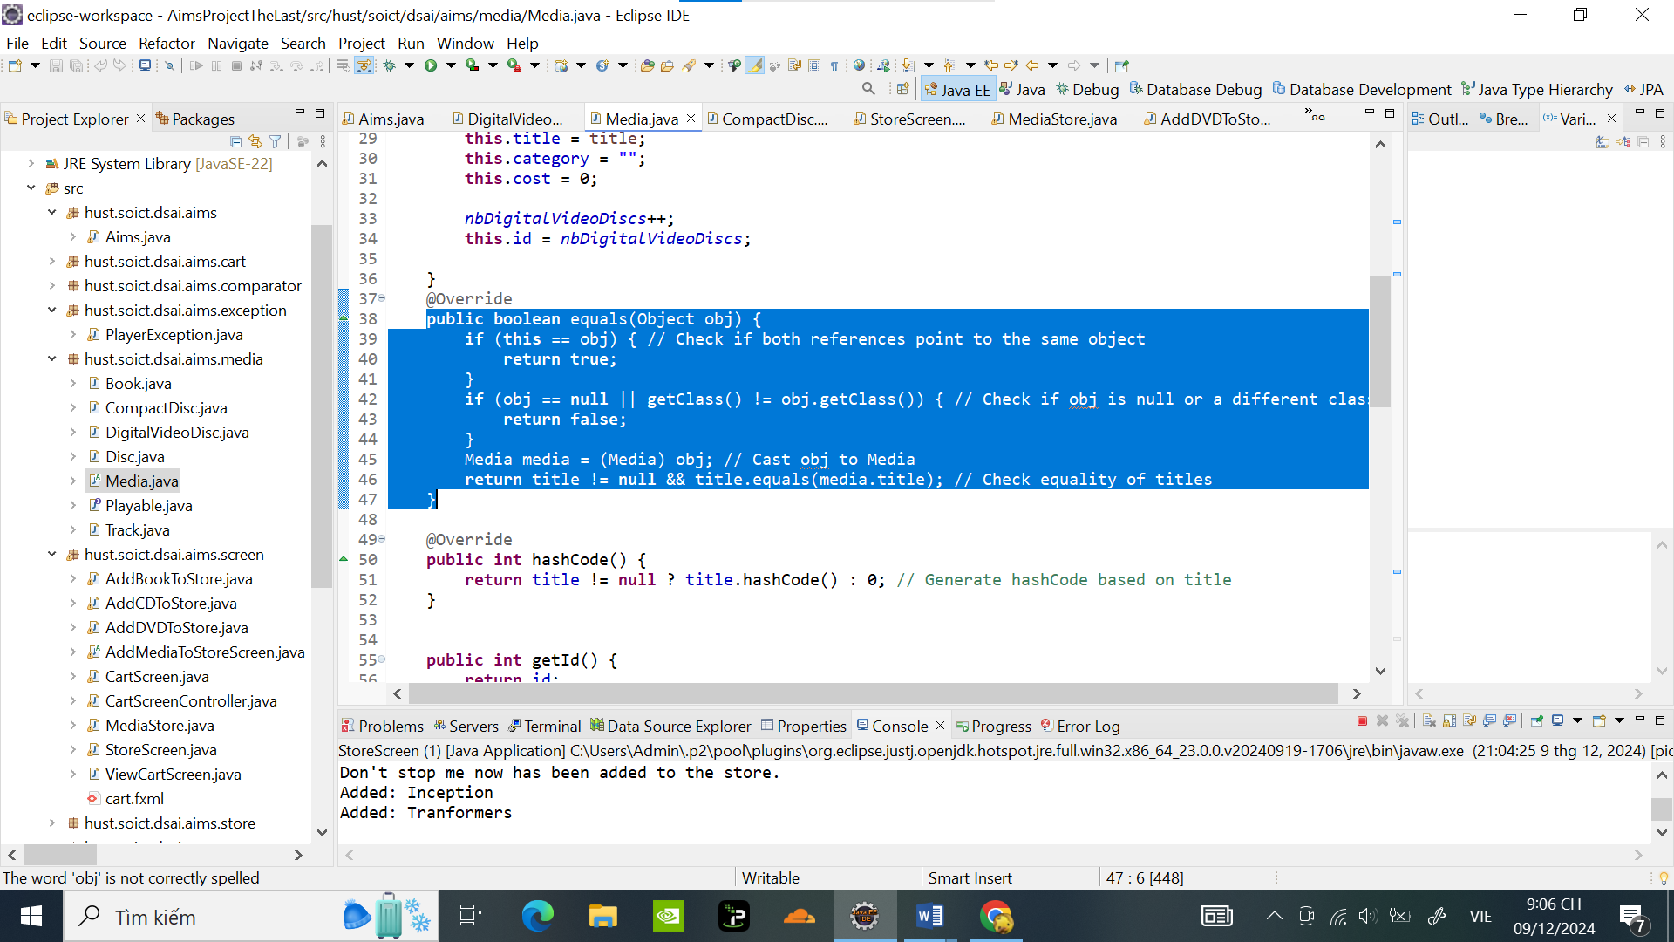

Code hiện thông báo lỗi trong Store khi thêm Media bị trùng:

**public** **void** addMedia(Media media) {

**if** (!checkMedia(media)) {

itemsInStore.add(media);

System.***out***.println(media.getTitle() + " has been added to the store.");

} **else** {

// Sử dụng JOptionPane để hiển thị thông báo khi media đã tồn tại

JOptionPane.*showMessageDialog*(

**null**,

media.getTitle() + " already exists in the store.",

"Error",

JOptionPane.***ERROR_MESSAGE***

);

}

}

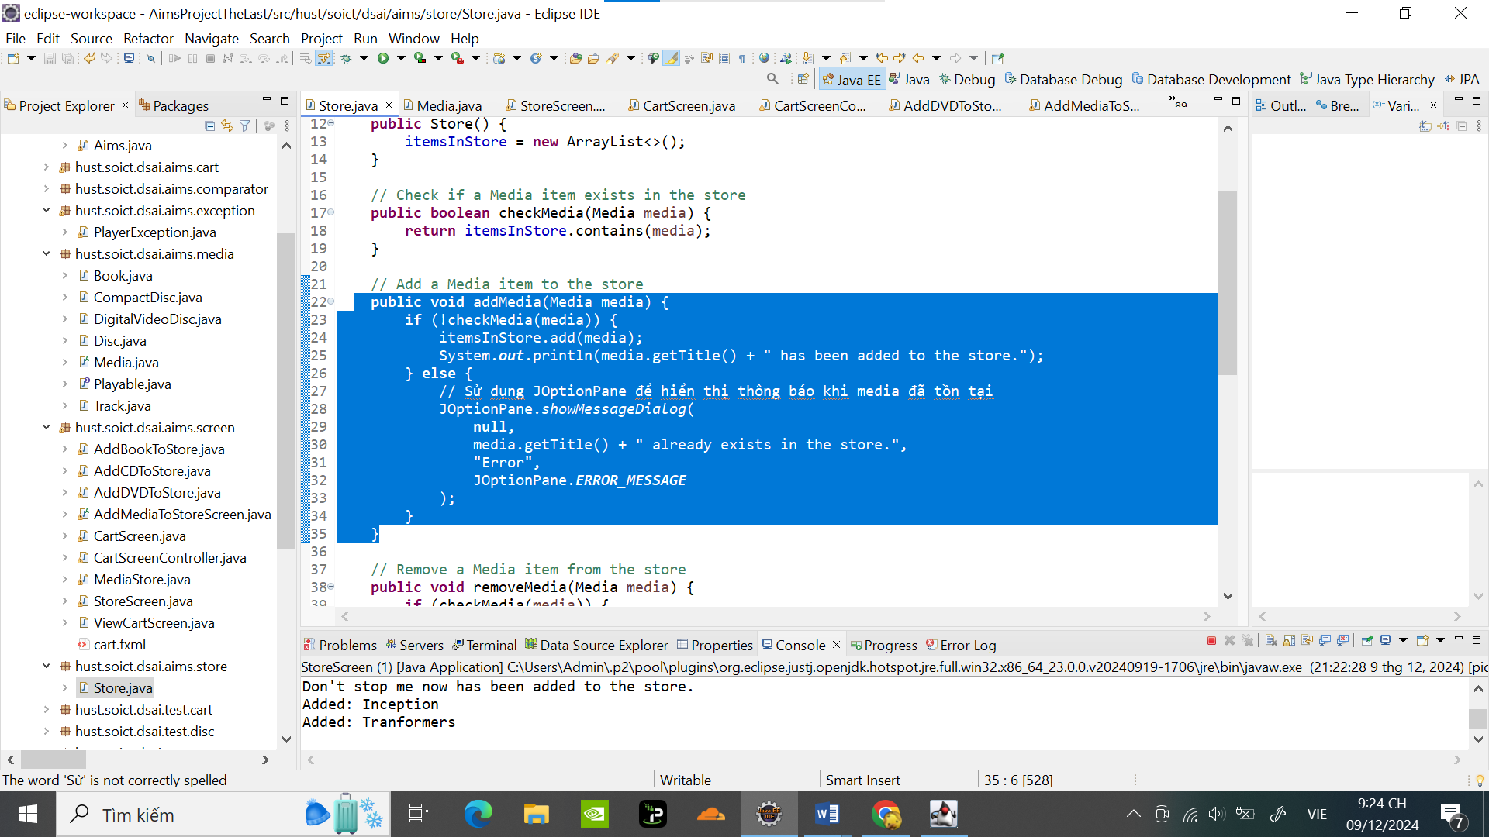

1 Ví dụ về thêm Doraemon bị trùng :

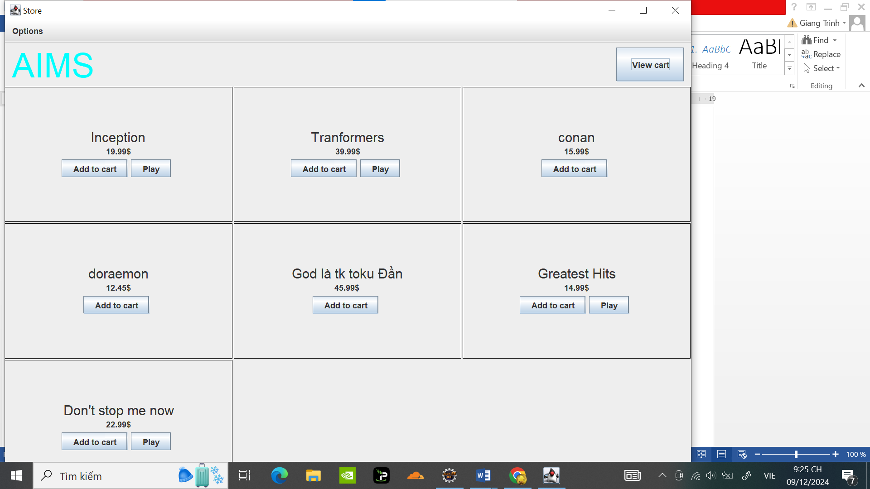

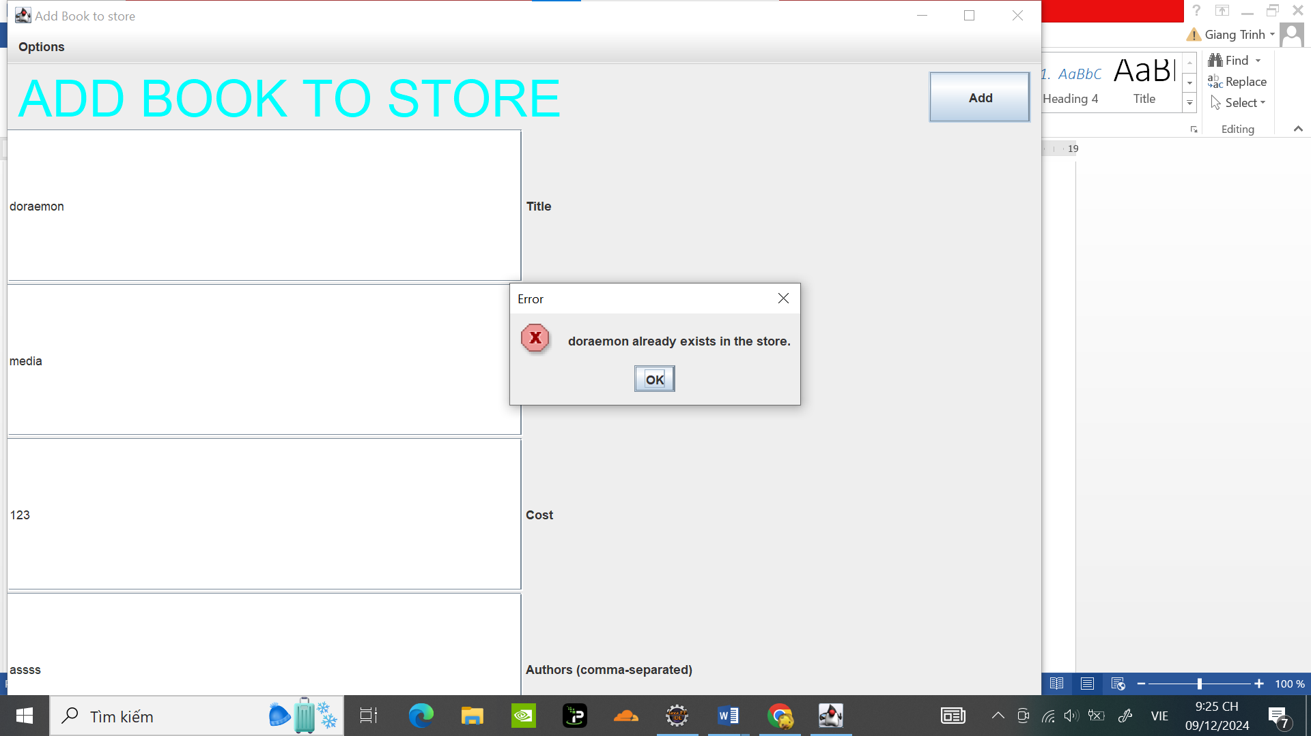

# Reading Document

(Đọc tài liệu )

# Update Aims class diagram

